Garden City Group

20/20 Training for Ops Leads

Practicum
Corporate Training

1531 Utah Ave. South
Seattle, WA 98032
(888) 404-8013
www.gcginc.com

Table of Contents

Overview 2
How to Use This Guide 2
Layout of 20/20 2
Getting Access 3
Access at the Beginning of a Project 3
Getting Around 3
Getting Help 4
Terms 4
Mechanics 5
Table Columns 5
Searches 7
Image Viewer and Bookmarks 9
Classifications 11
Label Multiple Pages 11
New Documents from Images 12
Moving Docs to a Different Record 13
Combining Documents into a Single PDF 14
Reordering Pages 15
Reports 17
Frequently Used Reports 18
Notifications 18
Working in 20/20 19
Workflows 19
Claim Entry Workflows 20
Claim Entry Review Workflow 23
Claim Processing Workflow 23
Claim Processing Review Workflow 23
Deficiency Processing Workflows 23
Deficiency Review Workflow 24
Admin Mail Workflow 24
Exclusion Processing Workflow 24
Exercises 24
Workflow Considerations 25
Name/Claim/Related Name Records 25
Numbering Conventions 26
Update Names and Addresses 26
Changing Work Assignments 27
Reassign to a Peer 27
Reassignments by a Lead 27
Remove Assignments in Bulk 28
Objections 29
Exclusions 29
Database Concepts 30
Project Setup 31
Pre-Setup 31
Adding Info to the Project 34
Project Overview 34
Project Services 34
Assigning People and Roles 34
Cloning 35
Adding People Individually 36
Assigning Roles 36
Assigning a Role to a Group 36
Key Events 37
Upload Key Documents 38
Claim Entry Forms 39
Planning 39
Overview of the Form Creation Process 39
Planning the Form 40
Using the Claim Form Configuration Tool 45
About the Templates 45
Building the Form 45
Headers and Spacers 49
Text Headers 49
Create Multiple Pages 49
Text Only Items (Spacers) 50
Data Entry Fields 52
About Data Entry (Non-Table) Fields 52
Add a Number Field 53
Add a Checkbox 54
Add a Drop-down Field 55
Add a Button Group 56
Tables 57
Build a Table Shell 57
Set Column Properties 59
Business Rules (aka If Tests) 64
Create a New Condition-Reason 65
Mapping Condition-Reasons 67
Promoting the CE Form 68
Status 68
Getting Ready for Promotion 70
Promoting the Form 70
Changes After Promotion 70
Verify Condition-Reasons are Applied 71
Workflow Descriptions 79
Claim Entry Workflow 79
QA for Claim Entry Workflow 80
Claim Processing Workflow (formerly, “doc review”) 80
Deficiency Processing and Review Workflows 81
Jetvision Processing New/Reveiw Workflows 82
Admin Mail Workflow 83
Exclusion Processing Workflow 83
Elec Batch Processing Workflow 83
Claim Entry (CE) Form Checklist 85
Claim Form Planning Worksheet 87
Building Blocks for Claim Entry Forms 89
“Add Item” Field Descriptions 93
Project Party Mapping 95
Condition Reasons 100
Index 101

Chapter
1

Overview
This chapter sets the foundation for the course
t
His guide is intended for Operation (Ops) Leads who need to learn how to use the 20/20 application to run their projects. Because many learners might already have a working knowledge of GCG’s CLASS application, where a comparison is helpful, that information is included; otherwise, this guide is geared toward learners who have no knowledge of CLASS.
Numerous exercises are woven into this guide so you can practice creating specific scenarios as you learn. Less scenario-driven instruction can be found in the online Help in 20/20.

How to Use This Guide

icon key
Valuable information
Tips and tricks
Exercises
Things to avoid

This guide is the companion text for an instructor-led course, meaning that learners will use this guide to perform exercises during the live course. The guide is also expected to provide reinforcement after the course to help learners recall and master the material that was presented in the classroom.
This guide uses icons as a way to make certain types of information easy to find. The key to the left provides the meaning of these icons.
Words in bold font refer to a specific tab, page, field, title, or other onscreen item in 20/20.

Use the colored tabs to know where you are in 20/20. When a tab is active, it changes from gray to orange

Layout of 20/20
Understanding where to access and manage information in the 20/20 application will help you move around quickly and be more efficient. The following image explains the major activity that happens in each tab of the application.

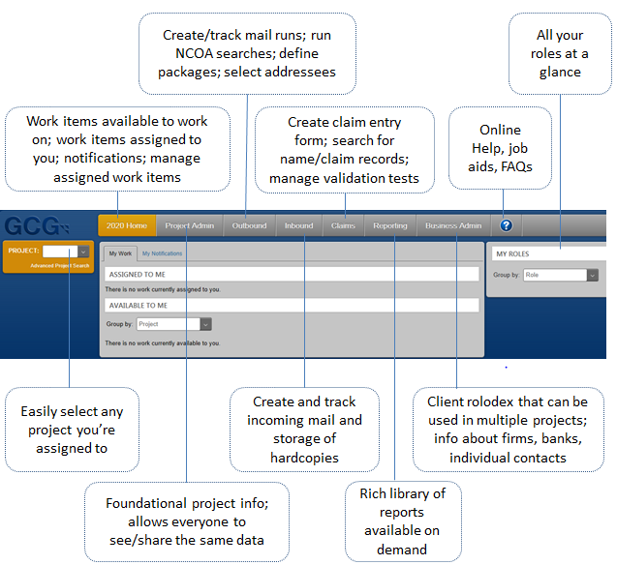

Getting Access
When new people join GCG, they are added to the Active Directory for email and such. We use the Active Directory to grant access to the 20/20 application. As soon as new people have email, they should be able to use the following link to get started in 20/20 (production or live environment) at http://gcg2020/.
The Active Directory is updated every evening. If you have problems with access, send an email to SeattleNetworksTeam@gcginc.com.
For this course, we’ll be working in a “sandbox” copy of 20/20 called UAT at http://gcg2020uat/. For more information about UAT, see “Working with PROD and UAT.”

Access at the Beginning of a Project
When we receive a project that will be put into 20/20, the following happens:
- The Project Administrator (Mellissa Velo-Simpson) creates the new project in 20/20 via the Project Admin tab.
- As part of creating the project, the Project Administrator assigns the Ops Lead and QA Lead to the project.
- The Project Administrator sends out a Project Startup memo that includes a request for the DBAs to create a database for the project.
- The Ops Lead creates the claim entry (CE) form, assign their team to the project, and add project details as needed.

Getting Around

Avoid using Chrome as your browser. 20/20 only works correctly in IE.
20/20 is designed to run in Internet Explorer (IE), so you must use IE as your browser.
However, IE controls are not always compatible with 20/20. In certain pages, using an IE control, such as the Back button, could cause data corruption. Therefore, it is best to avoid using any of the IE controls when you use 20/20.
Instead of clicking the Back button in the IE browser, you can navigate away from a page by either clicking a different 20/20 tab or clicking a linked breadcrumb, which usually appear in the top left corner of a page.
You might find it helpful to open multiple instances of 20/20 if you manage more than one project. If you open one IE tab per project, you can keep a project open while you work in the other project in a separate tab. Be careful, however, to avoid working in a single workflow item in more than one tab, as this can lead to potential data corruption.

Getting Help
Getting help is easy:
- To make suggestions for improvements to 20/20 and for general questions, send an email to 2020Questions@ggcginc.com.
- For technical issues, send an email to 2020Support@gcginc.com.
- For questions about the online Help, click Contact Us at the bottom of any Help topic.

Terms
To clarify the various terms related to claim forms, we will differentiate between claim forms as follows:
- Claim form draft is the hardcopy version of the claim form from the client/court at the start of the project.
- Claim form is the hardcopy version created by the Graphics team that we mail to potential class members, who fill it out and mail it back to GCG.
- Claim form image is the scanned image of the document that is completed and sent to us by potential claimants, queued up in 20/20, and ready for doc assignment and processing.
- Claim entry (CE) form is the form created by Operations in 20/20 using the Claim Form Configurator so the processors have a place to enter data from claim images.
- Online claim is the Web version of the claim form that allows class members to do their own data entry, then submit the claim electronically.

For more about 20/20 terms, see “20/20 Lingo” in the online Help
- Claim record is a record stored in 20/20 that contains all of the claim-level details for each claim filed (not to be confused with the name record, which contains personal info about each claimant/potential claimant).
Chapter
2
Mechanics
This chapter will help you understand how to use certain widgets in the 20/20 application

Table Columns
Most of the tables in 20/20 provide one or more of the following mechanisms that allow you to rearrange information in a table:

Select ‘Contains’, then enter “dan”. The results will include “Dan,” “Danielle,” “Daniela,” “Jordan,” etc.
- Ascending/Descending/Default Sort Order – A triple-toggle (three clicks) that reorders a column alphabetically, from A-Z, Z-A, and default sort, which reorders alphabetically based on the Sort Name field. If Sort Name is used, the column is alphabetized according to the text in the Sort Name field. Some tables only have a two-way toggle, with only ascending/descending order.
- Show/Hide Columns – Lets you control what columns are shown and hidden in reports.
- Filtering – Narrows the content of a table by temporarily hiding the rows you don’t want to see. Does not rearrange the column.
A few things to consider when using filters:
- A filter applies to only one column, but you can set filters on multiple columns to specify your criteria effectively.
- Only one filter can be active per column. A filter persists until you clear it.
- Filters ignore capitalization.
- If a filter produces no results, open the filter again, and click Clear to go back to the original table.
- Completing the AND/OR fields is optional, but they can provide valuable filtering capabilities. Use AND to add a second filter value. Use OR to add an alternate filter value.

Practice sorting a column in ascending/descending order:
- In 20/20, click the Claims tab.
- In the Project drop-down, select “COC.”
- In the left menu, click Name/Claim Search.
- In the Name field, type “Smith.”
- In the search results, look at the Name/Address Line 2 column and remember the first 3-5 rows. Notice that they aren’t in alphabetical order.
- Click in the header cell of that column. An up arrow appears just to the right of the column title and the column is now in alphabetical order.
- Click again in the same column header. The arrow indicator is now pointing down, and the results are now in reverse alphabetical order.

When you apply filters, data remains hidden until you clear the filters.
- Click a third time in the same column header. This time, the indicator has disappeared, and the results are back to the original, default order.
- Try sorting a couple of other columns.
Practice hiding and showing columns:
- Click the Reports tab.
- In the Project drop-down, select “COC.”
- Click the RUN link for the Batches Within a Box report.
- At the top of the column you want to sort, click the down arrow to the far right of a column title.
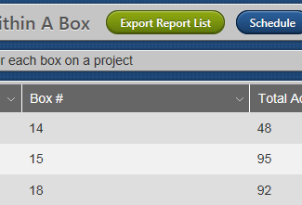

- In the popup menu, click Columns.
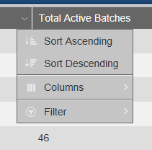

- Clear the checkboxes for the following columns:
- Total Voided
- Grand Total
- In Progress Batches
- Repeat steps 4 and 5 to replace the three columns you hid.
Practice using the filter feature:
- Click the Project Admin tab.
- In the Project Code field, enter “coc.”
- When the COC project opens, hover over the left Project menu item, then click Assign People to open the Project Assignments page.
- Scroll through the table, and notice the number of people who are assigned to the project.
Next, we’ll use the filter feature to find someone in the Dublin office who has permissions to process returned mail.
- Click the down arrow to the left of the title for the Office column.
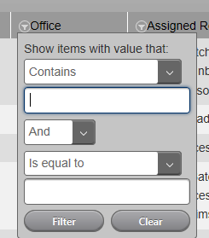

- In the first Is equal to drop-down, select Contains.
- In the first blank field, enter “dublin.”
- Click Filter. Now, only the Dublin employees are listed.
- In the Assigned Roles column, click the filter button, and in the first Is equal to drop-down, select Contains.
- In the first blank field, enter “return” then click Filter.
The table now contains only the people in Dublin who have permission in the COC project to handle returns. We could further narrow the list to remove the Call Center people by adding a third filter for the Department column.

Searches
The search function in 20/20 has the following characteristics:
- The columns in search results can be filtered in ascending/descending order, as we’ve already seen.
- You can search for names two ways:
  - Enter text into the Name field to search for that exact string of text in first or last names only.
  - Enter text into the unlabeled name/address field (under the Search all 5... checkbox) to search for that text string in names and addresses.
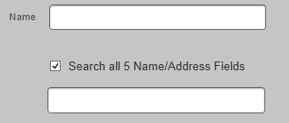

- Additional search criteria are available by clicking More Criteria at the bottom of the Search page.
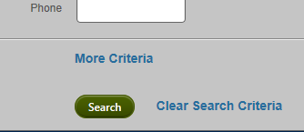

- Search fields are cumulative. For example, if you enter “Cornwell” in a name/address field and enter “NC” in the State/Subdivision Code field, the results will contain records with the text "Cornwell" in the name or address, and the state is “NC.”
- Search criteria persists until you clear it (click Clear Search Criteria), delete it from a field, or reset drop-downs to Select.
- Search results can be exported to an Excel file by clicking Save as Spreadsheet.
- Wildcards don’t work in 20/20; however, the search capabilities allow you to search on many more data points than in CLASS. You can enter search criteria in more than one field to narrow your search results.
Practice performing several searches:
- Click the Claims tab.
- In the Project drop-down, select “COC.”
- In the left menu, click Name/Claim Search.
- In the Name field, enter “smith.”
- Click Search. Note that the search results list only the first 300 records, but they are narrowed to records whose first or last names include “smith,” for example “Smithy” and “Goldsmith” and “Smith-Klein.” Also, none of the search results have any claims associated with them. (The Claim link is missing from the left column.)
- Scroll up to the search fields, and click More Criteria.
- Under the Claim section, in the Claim Status field, select Claim Entered.
- Click Search again. Now all the records in the search results have claims associated with them, in addition to containing “smith” in the first or last name.
- Click the Search link to return to the Search page.
- Move “smith” from the Name field to the field below the checkbox labeled Search all 5 Name/Address Fields.
- Click Search. The search results now include records that have “smith” in any of the name or address fields, in addition to having an associated claim.
- Click the Search link to return to the Search page, then click Clear Search Criteria at the bottom.
- With all fields cleared, in the Name section, select Yes for the Exclusion drop-down.
- Click Search. Now the search results include only the exclusions for the project.
Can’t see the Name/Claim Search menu item?
The Name/Claim Search menu item is only available in the Claims tab, and only after you select a project. To get the left menu pane to appear in the Claims tab, select a project code from the Project drop-down in the 2020 Home tab or the Claims tab.

Image Viewer and Bookmarks
The Image Viewer allows you to:
- Click through the entire sequence of pages in a document
- See thumbnails of each page
- Rotate pages 360 degrees; zoom in and out
- Add bookmarks and link them to specific lines in a claim record so reviewers can quickly re-verify information.
- Bookmarks work in claim records and admin mail, but not in name records
- Classify pages and ranges of pages
- Create a new document from an image

Practice using the Image Viewer and creating a bookmark:
- In the COC project, search for claim number “92B4AAB9C4.”
- In the search results, click Name.
- Expand the Inbound Documents section, then click View Document to open the Image Viewer.
- Page through the image by clicking on the thumbnails and by clicking the down arrow in the toolbar.

- Rotate the image using the rotation widget.
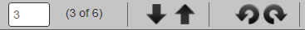

- Use the plus (+) and minus (-) signs (bottom of the page) to zoom in and out on the page.
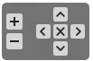
- Use the directional arrows to move around in the image, finishing with the center X button to return to the center of the page.
- To add a bookmark, locate the signature in the image. We’ll create a link that will connect to the claim record.
- From the Add Bookmark panel, drag the bookmark icon and drop it next to the information.
- In the New Bookmark dialog, enter a label for the bookmark in the Name field.
- (Optional) In the Description field, describe the bookmark or enter a related note.
- Click OK.
- Verify that the bookmark name now appears in the Current Bookmark list in the right panel.
- Note the name and name/claim number associated with the image, and continue with the following procedure.
Next, we’ll connect the bookmark to a claim record:
- In the Claims tab, search for and reopen claim number 92B4AAB9C4.
- Click the Claim link.
- In the Claim Form section and in view mode (rather than edit mode), click Bookmarks to open the right panel that lists the bookmarks that are in the image.
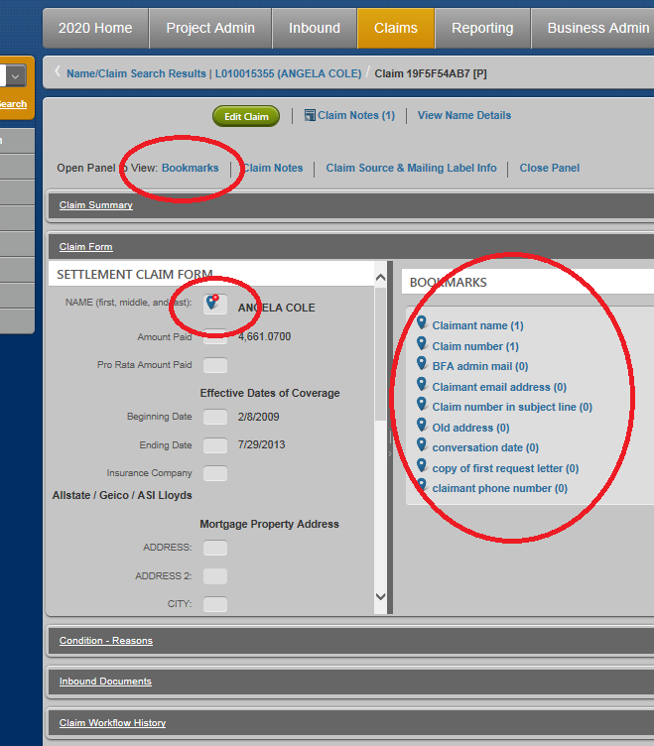
- Drag bookmark icons from the Bookmarks panel to the associated item in the claim record. Multiple bookmarks can be applied to a single line in the claim form.
- Do one of the following to see the bookmark in the image:
- Click any bookmark name in the Bookmarks panel to open the image with the bookmark highlighted.
- Click any bookmark to open a dialog where you can double-click the bookmark name to open the image with the bookmark highlighted.
- Keep the image open for the next exercise.

You can also move documents to a new record. See “Moving Docs to a Different Record.”

Classifications
The classification feature in the Image Viewer allows you to apply tags to selected pages and create new documents.

Label Multiple Pages
You can apply a label to a range or to multiple pages with a single click. This allows you to establish a protocol for the processors to tag certain parts of the images to make them easier to find.
For example, the GMO project required claimants to send us a wide variety of documents, such as police records, hospital records, photo evidence, auto repair records, etc. The Lead created a predefined list of documents as classifications that allowed processors to tag multiple pages with a single classification by defining the range, then selecting the classification once from the drop-down list. Using classifications saved a lot of processing time compared to bookmarking.
The default values currently defined in the drop-down list for all projects are simply “Supporting Docs” and “Other,” but the Systems team can add additional classifications for your project. You’ll need to provide them with a name and description for each classification you want to create.

New Documents from Images
You can copy a section of an image to create a new document (image) that is separate from the original, without altering the original when a client requests a specific portion of a document.
For example, if a lawyer represents multiple claimants, the lawyer might send us a stack of documents that apply to multiple clients. When those documents are scanned into 20/20, they are scanned in as a single document. Once it’s in the system, we might not want to assign the giant document to all of the lawyer’s claimants, so we break it up into multiple documents and reassign those documents to the appropriate claimants.
You can copy a section of a document to create a new, separate document, without altering the original. For example, you might need to create a separate document for a third party.
Practice classifying a range of pages:
- In the image from the last exercise, page down to page 5.
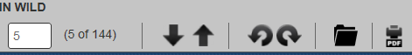

- Click the folder icon at the top of the screen to open the Image Classification dialog box.
- From the Image Classification drop-down, select Supporting Document.
- In the Last Page field, enter “9.”
- In the Document Type field do nothing.
- Deselect the Create New Document checkbox.
- Click Save Classification.
- In the Document Classifications pane to the right, the range is now listed as “Supporting Document (5-9)”. You can click that link to jump directly to page 5.

Practice classifying specific pages and creating a new document:
- In the Image Viewer, go to page 11.
- Click the folder icon to reopen the Image Classification dialog box.
- From the Image Classification drop-down, select Other.
- Click Enter pages, and in the Enter pages field, enter “11, 13, 15.”
- Select the Create New Document checkbox.
- From the Document Type drop-down, select Other.
- Click Save Classification, then Create New Document.
- Go back to the Inbound Documents section of the name record.
- Confirm that the new document, named “Other,” is now listed.
- Keep the image open for a future exercise.

Moving Docs to a Different Record
Use this procedure when a document is assigned to the wrong record/name, or when you need to associate multiple records/names to a single document. Documents can only be assigned to a record that already exists in 20/20.
- In the left Project drop-down, select the project you want to update.
- Go to Claims > Name/Claim Search > [enter search criteria].
- In the search results, find the record you want to update, and click Claim to the left.
- In the Inbound Documents section, find the document you want to change, and click Edit Doc Assignment to the left.
- In the Document Assignment Edit page, click Open Image (to the far right) to see the claim form.
- Enter criteria to search for the new record that you want to associate with the document, and click Search.
- In the search results, find the new record, and click Assign to Name to the left.
When you assign a new record to a document, an instance of the new record appears in the unnamed assignment pane above the search results in the Document Assignment Edit page.
Note that assignment instances are prefaced with one of the following notations:
- (N) - Every record will have an (N) name instance, which reflects the Name ID associated with the active name/record. Multiple names can be assigned to the record.
- (C) - If a claim is associated with the name/record, a (C) claim instance is displayed with the Claim ID. Multiple claim instances can be assigned to the record when multiple people are assigned to a claim.
- To assign another record to the document, click Search, and repeat steps 5-7 for each additional assignment.
- When you're finished, click Update Assignments.

Combining Documents into a Single PDF
You can create a single PDF that contains multiple documents to print or email to a stakeholder. For example, if an attorney wants to see the documents for everyone who has an exclusion, you can gather the documents into a single PDF that you can easily email to the attorney.
To see the menu item, called Create PDF, one of the following roles is required:
- Ops Lead, Primary or Secondary
- QA Lead, Primary or Secondary
- PDF Creator (new)
Practice creating a multi-doc PDF:
- Go to the Claims tab.
- In the Projects drop-down, select “COC.”
- In the left menu, click Create PDF.

The numbers you enter must contain 8–10 alphanumeric digits, be all claim IDs or all name ID (not mixed), and be separated by spaces, commas, semi-colons, or hard returns.
- In the ID Type section of the Create PDF from Documents page, select the Claim Number option.
- In the ID Numbers field, type the following numbers:
- 9D0110F5C8
- 92B4AAB9C4
- 0CF4B4DBBB
- In the Document Types section, select all types, except Exclusion.

The page will only display doc types that are actually in the project. The Web Upload option will include electronically received documents in the following file formats: .tiff, .tif, .jpg, .jpeg, .png, .gif, .bmp (but not .pdf).
- Click Create PDF.
- When you see the following prompt at the bottom of the screen, click Open, and save the file wherever you want. (Clicking Save will save the file to your Downloads folder.)
- In the resulting PDF, click the bookmark icon on the left to see the documents included in the PDF, listed in alphabetical order according to the first name in the Name field.
- If a person has more than one document in the PDF, their documents are shown in the same order as the Document Types list (alphabetically), for example, first the Admin Mail, then the Claim, then the Exclusion.
- The page number is displayed at the top of the page with the name and ID number.
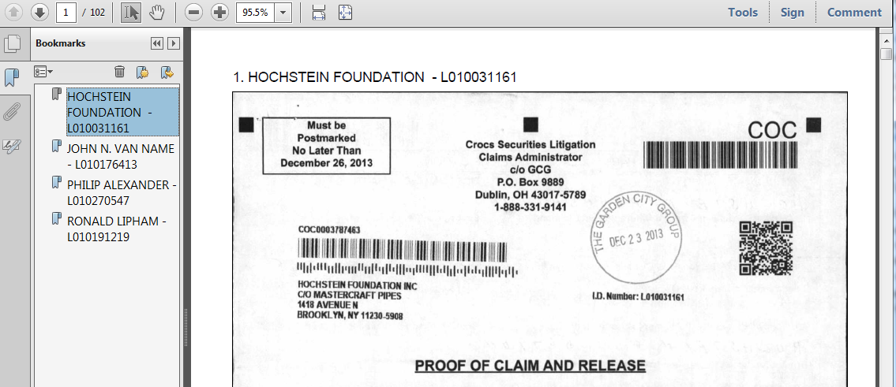

Reordering Pages
In the Image Viewer, you can easily reorder the pages of any document.
Practice reordering pages:
- If you don’t have the image still open, go to the COC project in the Claims tab, and search for claim number “92B4AAB9C4.”
- In the search results, click Name.
- Expand the Inbound Documents section, then click View Document to open the Image Viewer.
- At the top of the thumbnail panel, click Reorder Pages.
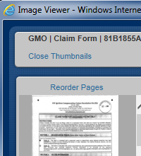
- In the thumbnail panel, drag and drop page 3 into the position of page 1.
Notice that as soon as you move a page, the Save Order link appears at the top of the thumbnail panel.
- Click Save Order, then Continue.
The page numbers are regenerated to reflect the new order. Bookmarks are retained. If the pages were included in a classification, they are also retained, but a new link might appear in the Document Classifications panel.

In very large documents, swapping adjacent pages is fast, but moving pages from one end of a large document to the other end might take some time.
For example, if page 4 was originally in a classification called “Eye Witness” that included pages 4-10, when page 4 is moved to page 3, a new classification link is created for page 3, titled “Eye Witness (3 -3)” and the original classification link changes to “Eye Witness (5 - 10)”. Classifications created going forward will use the newly saved page order.
- Keep the image open for the next exercise.
Practice reordering pages that are classified:
- At the top of the thumbnail panel, click Reorder Pages.
Notice in the Document Classifications panel that pages 5-9 are classified as a “Supporting Doc.”
- In the thumbnail panel, click Reorder Pages.
- Drag and drop page 5 to the position of page 2.
- Click Save Order.
Notice in the Document Classifications panel that the former page 5 has been renumbered as page 2 with its own “Supporting Doc” classification, and that pages 6-9 remain classified as a “Supporting Doc.”

Reports
The Reporting tab provides a library of predefined reports that can be run for projects. The list you see depends on the projects and roles you're assigned.

For a list of descriptions of available reports (for example, whether the report applies to consumer, securities, or bankruptcy cases), generate the Report Catalog report
The RUN links on the left are blue for each report that is available to you. If the RUN link is grayed out (inactive), the report might be available, but you need to first log in to a project.
Many reports contain logic that limits the contents to one million rows because that's the limit for Excel spreadsheets. Columns that are titled "Top 1 Million Names" or "Top Million Claims" help alert you to the constraint.
Reports are always opened in a new browser tab. After you generate a report, you can get back to the Reporting tab by simply clicking the browser tab to the left of the tab for the active report. The active report will remain open until you close its browser tab.
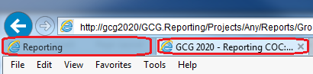

Practice generating a report:
- In the Reporting tab, select COC from the Project drop-down.
- In the Search field, enter the term “condition.”
- In the search results, click the RUN link for the Applied Condition Reasons – Detail report.
- Take a look at all the variables that are available for sorting through the claims. Without making changes, click Run Report.
Despite the fact that many reports provide a preview page that allows you to set filters/parameters, the only way to get the full report is to click Run Report without changing any of the defaults. If you make any changes to the filters/parameters, the resulting report is a sub-set of the full report.
- In the resulting report, click the down arrow in any column heading and hover over the Columns menu item to open the list of columns in the report.

Note that the list only contains the claims in the project that have condition-reasons applied
- Deselect the several columns to see how they disappear:
- Click Specify Report to return to the page of variables.
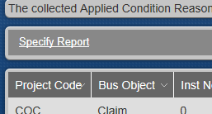

Frequently Used Reports
Some of the most frequently used reports:
- 2020 Weekly Status Report (or a customized version for the project)
- 2020 Weekly Remail Statistics
- Applied Condition Reason - Details
- Exclusion Requests Processed
- Outbound Mailings
- Production Report – Operations Version (currently disabled)
- De-Dup reports
- Late Claims Listing – “What If” Report

Notifications
The 20/20 system generates alerts in the 2020 Home > My Notifications tab based on specific triggers built into the 20/20 workflows. Alerts are specific to projects and roles. For example, when the Inbound team processes a batch of Admin Mail, the Ops Lead for the project receives an alert as a heads-up to expect new work items in the Admin Mail workflow. The My Notifications tool can only receive, not send, alerts.
When you receive an alert, a popup temporarily appears in the lower left corner of your screen, and a red circle appears on the 2020 Home tab with the number of unread alerts that you have. Click My Notifications to view and archive your notifications.
If you need a new alert created, contact the 2020SeattleIT@ team.

Chapter
3
Working in 20/20
This chapter will help you understand the workflows in 20/20, the roles related to workflows, and considerations for workflows
In 20/20, workflows replace the CLASS notion of queues, but with some differences. Understanding workflows is important because they have an impact on how the claim entry (CE) form is set up.

Workflows
The 2020 Home > My Work page contains links that represent documents grouped in predefined workflows. The links become visible to the people depending on their roles.
In 20/20, items are processed one-by-one instead of in batches of ten, as they were in CLASS. Clicking a link in the Available to Me section opens a single work item so the processor can move it through a predefined set of tasks (usually just two). These tasks are assigned to people who do their part to move each work item to the end of the workflow.
Currently, a work item will show up in the Assigned To Me section under the following conditions:
- The work item was opened by a processor or Lead in the Claim Entry, Claim Processing, or Deficiency Processing workflows, then reassigned to another person via the Assign To button.
- A Lead reassigned the work item to a new person via the Workflow Management tab under 2020 Home.
- The processor clicked the Back or Refresh buttons in IE, or they closed the IE tab or browser before processing was complete. These actions can cause work items to be stuck in the Assigned To Me section.
If you open a work item from the Available to Me pool, you can click any tab to send the item back to the pool as long as you haven’t made any changes. Only Leads can move an assigned item back to the Available To Me pool. For instructions, see Changing Work Assignments.
The following roles are required to see the workflows in the My Work page at the processor level (Leads and Supervisors not included):
- Claims Entry role for the Claim Entry – Ready for Assignment and Ready For Processing workflows
- Claims Processor for the Claim Processing – Ready for Assignment and Ready To Process workflows, and Deficiency Response workflows
- Claims Entry QA and Claims Process QA roles for the respective Ready for Review workflows
- Admin Mail Exclusion Processor role for the Admin Mail workflow and Exclusion Processing workflow
You might be tempted to assign yourself all these roles so you can monitor the workflows. Instead, use the 2020 Home > Workflow Management sub-tab, which provides an up-to-the-moment count of assigned and available work items in every workflow of your project.

For a handy table that explains the workflows, see Appendix A
The following workflows are currently defined in 20/20.

Claim Entry Workflows
In the Claim Entry workflow has two parts (Ready for Assignment and Ready for Processing), and is designed for projects that need assignments and processing done by different people.
- If the barcode on the incoming claim form cannot be read, the image becomes a Claim Entry – Ready For Assignment work item. (In CLASS, this was known as “Form ID.”) Processors search for the name record.
  - If a record exists and the assignment is successful, the work item goes to Claim Entry – Ready for Processing to create a new claim record.
  - If no record is found, the processor clicks Skip to create a new claim record. When completed and saved, a new name record is automatically generated/saved.
- If the barcode can be correctly read, the image becomes a Claim Entry – Ready For Processing work item. The processor enters data from the image (including transaction data) into the 20/20 record, then confirms the signature.
- Bookmarks can be created any time by the processor in the image. Bookmarks can then be added to the claim record after the claim record is saved for the first time.
- When the claim entry assignment and processing are complete, the next work item (if one exists in the Claim Entry workflow) is then checked out to the processor. The completed work item is moved to the Claim Entry – Ready for Review workflow for the QA team.

This flowchart illustrates the Claim Entry workflows so you can see how they intersect. Note that the Claim Processing workflow is a separate workflow that comes after the Claim Entry work is QA’d.

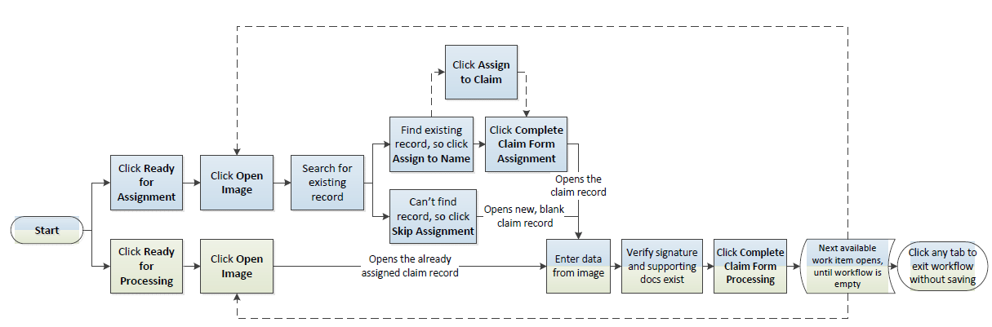
Key:
Blue – Claim Entry - Ready for Assignment workflow
Green – Claim Entry - Ready For Processing workflow

Claim Entry Review Workflow
In the Claim Entry Review workflow, the QA team reviews the data entered by processors during the Claim Entry – Ready for Assignment and – Ready for Processing workflows, then either approves the work and advances the item to the Claim Processing workflow, or sends it back to the processor for rework.
All QA workflows allow reviewers to check out batches of 10 work items. Stats, including an accuracy rate, are displayed per processor to help reviewers determine whether to review all 10 items, just spot-check them, or approve/advance them without review.

Claim Processing Workflow
The Claim Processing workflow works the same as the Claim Entry workflow, except that the image is already assigned to a name record and a claim record.

This workflow skips the assignment phase
The processor can add bookmarks to mark the location of specific information in the image, then create connections in the claim record from the image to specific line items in the claim record.
When the processing and bookmarking are complete, the item is sent to the Claim Processing Review workflow.

Claim Processing Review Workflow
In this workflow, QA reviews the work done during the Claim Processing workflow, then either approves the work, which completes the lifecycle of the item, or sends it back to the processor for rework. If an item is returned to the processor, issues must be addressed, then the item is returned to the QA reviewer. If everything is approved by QA, the item is complete.

Deficiency Processing Workflows
Incoming mail is sent to the Deficiency Processing workflow if it is a response from a potential claimant to a Letter of Deficiency, which is sent when a record is incomplete after going through the Claim Entry/Claim Processing workflows.

This workflow allows bookmarking
The Deficiency Processing – Ready for Assignment and Ready for Processing workflows are very similar to the Claim Entry/Claim Processing workflows in that they allow a processor to assign images to name/claim/related name records, then enter information from the image into the claim record. If the deficiency is resolved by the additional documents, the processor then changes the status of the condition-reason to Resolved and adds a note to explain the situation.
If the deficiency is not resolved, the processor should also add a note before completing the assignment. Whether the deficiency is resolved or not, the completed item advances to the Deficiency Review workflow.

Deficiency Review Workflow
In this workflow, the QA team reviews, then either approves the work, which completes the lifecycle of the item, or sends it back to the processor for rework. If an item is returned to the processor, issues must be addressed, and the item is returned to the QA reviewer. If everything is approved by QA, the item is complete.

Admin Mail Workflow

This workflow allows bookmarking
This workflow is for incoming mail that is not a claim, a response to a deficiency, or a request for exclusion. The workflow is similar to the other Ready for Assignment workflows in that a processor can assign an image to a name/claim/related name record, but this workflow only allows you to edit name/related name records, not claim records. Also, this workflow doesn’t allow you to create new name/claim/related name records.

Exclusion Processing Workflow
This workflow handles exclusions. The Deficiency Processing – Ready for Assignment workflow allows a processor to assign an image to a name/claim/related name record, then edit the records as needed. Bookmarks can be added to claim records within the workflow.

Exercises
Practice using workflows:
Before starting, note the number of items that are in the COC workflows.
- Click the 2020 Home tab.
- In the Available To Me section, click the Claim Entry – Ready for Assignment link for the COC project. These are claim forms that don’t have barcodes or with barcodes that weren’t read properly.
- Click Open Image.
- Using information in the image, search for an existing record.
- If no records are found for that person, click Skip Claim Form Assignment. A new, blank claim records is opened. Continue with step 6.
- If you find a record, open it to make sure that it matches the info in the image, then click Assign to Image, then click Complete Claim Form Assignment. The claim record opens. Continue with step 6.
- Enter data from the image into the claim record.
- Determine whether the signature and supporting documents exist, then record your findings.
- When you’re finished, click Complete Claim Form Processing.
- Verify that the number of items in the Ready for Review workflow has increased.
- Click the Ready for Review link as if you were on the QA team.
- Find your name, and click Approve for your row, then click Approve Items. The item you processed should now be reflected in the Claim Processing – Ready To Process workflow on the Available To Me section of the My Work page.
- In the Available To Me section, click the Claim Processing – Ready To Process link to check out an item.
- Without saving, click the 2020 Home tab. Notice that the item goes back to the Available To Me pool. Use this technique to exit any workflow safely.

Workflow Considerations
We have some flexibility when it comes to workflows, meaning that you can ask the Inbound team to direct incoming mail to the workflow of your choice for each project. If none of the predefined workflows will work for your project, the Systems team might be able to modify the workflow for you. The Systems team can also redirect already scanned documents to a different workflow, if necessary.

Name/Claim/Related Name Records
In 20/20, information is split into three types of records: name records, claim records, and related name records. Each type is treated as a separate entity, and each type has a different unique identifier:
- Name Records (formerly “NME”)
  - Information specific to claimants/potential claimants, including contact info, document tracking, and applied condition-reasons.
  - Name ID – A random 10-digit number, often starting with the letter “L”. Also referred to onscreen as Name Number, Claimant ID, Claimant No., and Claimant Number.
- Claim records
  - Information specific to the claim form, including transaction info, condition status, inbound docs, workflow history, etc.
  - Claim ID – A random 10-digit (non-sequential) alphanumeric identifier. Also referred to onscreen as Claim Number and Claim No.

- Related name records
  - Information specific to a non-claimant, which a person or organization somehow related to a claimant (such as an attorney, parent, spouse, etc.). They might be a payee, but they are not the actual claimant.
  - Related Name ID – A random 10-digit number, starting with an “X”. Any field labeled “Name Number” usually also accommodates related name IDs.

Numbering Conventions
In CLASS, ranges were typically used to specify claim type, and NMEs were sequential. For example, NMEs beginning with 1,000,000 were paper claims, and NMEs starting with 5,000,000 were electronically filed claims. In 20/20, Name/Related Name IDs are no longer sequential or in specific ranges. Claim IDs are also randomly generated, followed by one of the following letters that represents its origin.
For example, “F568D1F09 [P]” is a paper claim:
- Paper [P] – Claims received via snail mail and scanned into 20/20 by the Inbound team. (This is equivalent to INI in CLASS.)
- Electronic or ICE [E] – Only Security claim submissions, typically loaded by the Standout team and processed by the ELF team in Ohio.
- Web site [W] – Claims filed online.
- Manual entry [M] – Claims created via the Add Claim page instead of a workflow. (During the Jetvision Processing workflows, “M” indicates a Mail ID.)
- Initial data load [I] – Claim records created as part of the initial data upload when the project started.
Currently, if an initial data load for a project is used to create name records only, the claims that get created during the workflows will have claim IDs that end with [P]. However, if an initial data load also creates claim records, those claim IDs would end with [I]. This convention might change in the future.

Update Names and Addresses
Records can be updated outside of workflows, if necessary. Simply search for the record, open it, and edit it.
Practice updating a name record:
- Open the COC project, and click Name/Claim Search. (Refer back to the “Searches” section if you need help.)
- In the Name field, enter “smith.”
- Under More Criteria, in the Claim Status drop-down, select Claim Entered.
- Click Search.
- Click Name for the item you want to update.
- In the name record, click Edit Name.
- When you’re finished making changes, click Save.
Currently, 20/20 provides no way to track address history. Consider using a workaround. When you add the new address, consider keeping the old address, but edit the first field of it so anyone could tell that it’s outdated, something like, “OUTDATED MMDDYYY--826 Devonshire St”. Whatever you use, establish the convention in your project protocol and training so everyone does it the same way.

Changing Work Assignments

Reassign to a Peer
You’ll want to encourage the processors on your team to use escalations sparingly, only when further investigation is truly needed. Asking them to use the Reassign feature is a great way to avoid unnecessary escalations. If a processor has a question that a co-worker can answer, they can reassign the item to the co-worker, who can send it back to the processor with an answer.
Practice reassigning a work item:

Workflow notes are discoverable, so always be professional in the tone and word choices in all your notes
- In the My Work tab, open a Claim Entry – Ready for Processing work item.
- Select a co-worker from the Assign drop-down. Note that the list only contains peers who have the same role as you.
- Click Assign.
- In the Add Note dialog box, enter a question for a co-worker, then click Save Note.
The co-worker can add their answer to the Claim Notes, then reassign the work item back to you for completion.

Reassignments by a Lead
Leads can unassign and reassign people via the My Work > Workflow Management tab.
Sometimes (for example, when someone goes on vacation), you might need to move a work item out of someone’s Assigned To Me queue and put it back into the Available To Me pool so someone else can work on it. Only Leads can move a work item back to the Available To Me pool.
Practice moving a work item back to the Available To Me pool:
- Go to 2020 Home > Workflow Management.
- In the Display field, select Assigned Work.
- In the Project field, select “COC”.
- (Optional) Use the Workflow and Processor fields to narrow your search.
- Click Search.
- Locate a processor, then click their Unassign link.
- Confirm the action by clicking Unassign Item in the popup.
The processor’s name is now greyed out, and the item is sent back to the Available To Me pool.
- Now let’s practice a reassignment by reassigning the item to yourself. On the greyed out row, click Reassign.
- From the Assign to User field, select your name, then click Reassign Item.
- Click the My Work tab, and notice that the work item is now in your Assigned To Me list.
- Keep the list open for the next exercise.
You can reassign a greyed out item only as long as you stay in the 2020 Home tab. As soon as you click to any other tab, the greyed out row will disappear, which means that you can’t reassign it. The item will, however, stay in the Available To Me pool for someone to work on it.
If you accidentally complete a work item prematurely (“Oops, I forgot something!”), you can use the Name/Claim Search feature to reopen it, as long as you remember something specific about the claim, like the name or claim number.
Otherwise, you have two options: 1) trust that it will be reviewed and reworked by someone on the team during the review workflow, or 2) contact 2020Support@ and ask them to reassign the work item to you. You’ll need to provide to them the project name, the time you did the accidental completion, and the name of the workflow.

Remove Assignments in Bulk
Multiple assignments can be removed (and sent back to the Available To Me pool) with a single click.
Practice:
- In the Workflow Management list, select a couple of check boxes on the left.
- Click Unassign Selected Items > Unassign Items.
This works the same as before, when you removed an individual assignment. You can reassign any of the greyed out items as long as you stay in the 2020 Home tab.
- Now select the unlabeled check box at the top left of the list. This selects every line visible on the page. We won’t do this, but if you were to click Unassign Selected Items now, all of the selected work items on that page would return to the Available To Me pool. (You can repeat for multiple pages, if needed.)

Objections
Class members can ask the Court to deny the approval of a settlement by formally filing a written and signed objection. We record objections in name records.
Practice recording an objection:
- Click the Claims tab, then enter “COC” in the Project drop-down.
- Click Name/Claim Search.
- In the Name field, enter “smith” then click Search.
- In the search results, click Name to the left of any row.
- Click Objection to open the Objection dialog.

- In the Requested Objection field, select Yes.
- In the Objection Date field, enter/select a date for the objection.
- Set the On Time? field to Yes. (Do this if the objection request is received on or before the Objection Deadline shown in the dialog box.)
- In the Objection Reason field, enter the explanation provided.
- When you're finished, click Save.

Exclusions
Members can remove themselves from a settlement by submitting a written, signed request before the deadline. We record exclusions in name records.
Practice recording an exclusion:
- Click the Claims tab, then enter “COC” in the Project drop-down.
- Click Name/Claim Search.
- In the Name field, enter “smith” then click Search.
- In the search results, click Name to the left of any row.
- Click Exclusion to open the Exclusion dialog box.
- In the Exclusion Type drop-down, select Primary.
- In the Exclusion Date field, enter/select a date of receipt.
- Set the On Time? field to Yes. (Do this if the exclusion request is received on or before the Exclusion Deadline shown in the dialog box.)
- In the Compliance Criteria section, complete the fields as if the requestor sufficiently met the requirements and signed their exclusion request.
- In the field under Notes, enter details about the exclusion.
- Click Save.

Database Concepts
Using 20/20 in its current state requires that you understand a little about how information is organized behind the scenes. You’ll need to understand this structure to choose correctly from drop-down lists as you build your claim entry (CE) forms and effectively apply business rules.
Information behind the scenes in 20/20 is organized into the following “chunks” or sections of a claim. The Systems team might refer to these as object types. You can think of the first five as “contact information” or the equivalent of NME in CLASS:
- Name – Applies only to the claimant’s name, tax ID (TIN), and a field that contains just the last four digits of their TIN
- Address – Applies only to addresses (that is, NameAddress 1-5, City, State, Zip, Country Code, and international address data)
- Phone – Applies only to phone numbers
- Email – Applies only to email addresses
- Alternate ID – Applies only to an alternate ID (for example, an account number)
- Clm Detail – Applies to transactional information in tables
- Claim – Applies to information in a claim record that isn’t contact information or transactional data
- Security – The transactional information in a security claim
We’ll explain more about how to apply this structure as we talk about CE forms and the business tests.

Chapter
4
Project Setup
This chapter explains all the activities necessary for setting up a new project, creating a claim entry form, and assigning people and roles

Pre-Setup
A person with the Project Administrator role (Jen Keough’s admin) creates new projects via the Add New Projects page in the Project Admin tab, and assigns the Ops and QA leads to the project. The data input during setup can then be viewed in the Project Details of the project in the Project Overview section (Project Admin > [enter search criteria] > Search).
Field Name | Action
Project Name | A shortened version of the title of the case (not to exceed 100 characters, can include numbers)
Project Code | The code assigned to the project, editable only while in Pending status
Access Code | The five-digit code for billing purposes, automatically assigned, editable only while in Pending status
Project Status | The current status of the project (explained below)
Billing Start Date | The date that the first billable work occurs after the contract is signed, usually a future date, but it can be backdated by manually typing a date; set by the admin during project setup
Date Approved for Start-Up | The date that the project was approved to move from Pending to Start-Up
Actual Go-Live Date | The date that the project moved from Start-Up to Active (Live)
Admin Office | The office that’s managing the project
Approver | The person designated by upper management
Case Related? | When the project was first set up, one of the following options was selected, based on whether the information about the legal case was already in 20/20:  - Yes, already in the system – A related case was already in 20/20, and this new case was linked to it.  - Yes, case not yet in the system – This is a new case, not in 20/20. This option assigns a type (consumer, bankruptcy, etc.) and subtype (anti-trust, ERISA, wage & hour, etc.) to the project. The project type determines which templates are available to you when you create your claim entry form in the Claim Form Configurator. This is the most frequently used option. If you can’t find the right template in the Claim Form Configurator, contact 2020Support@ and ask them to change the settings in the Case Related? field.  - No - The project is not related to a legal case. (This option is rarely used.)

When the admin finishes setting up a new project, it is automatically assigned a five-digit access code for billing purposes and set to the status of Pending. Ops Leads are responsible for advancing the status of their projects.
To move the project to the next stage, go to Project Admin, search for the project, and expand the Update Project Status section.
Descriptions of the states:
- Pending – This is the beginning stage for every project until the client signs a contract to retain us and management confirms that the project is official. All new projects are automatically given a Pending status.
  - Little or no billable work can occur in this state.
  - A few key personnel are assigned, usually only the Ops Leads, QA Leads, and System Leads.
  - Projects can be cancelled only if they are in a Pending state.
  - The project code and access code are editable only while a project is in Pending status. (Access codes are rarely changed, usually only when a project moves from CLASS to 20/20.)
- Start-Up – Advance the project to this state when it is official and billable. During this stage, Ops Leads set up the project infrastructure.
  - A project is moved to Start-Up only if the Primary Ops Lead and Primary QA Lead are assigned.
  - Assign personnel, secure PO boxes and phone number, build website, record phone messages in various languages, secure journal ads, and construct the project database.
  - This phase tends to last several weeks.
- Active (Live) – Advance a project to this state when we begin to interact with the public.
  - During this phase, notices are sent, claim forms are received/processes, and funds are distributed.
  - If you receive a warning when you try to advance a project to this state, the project has services that remain in a “To Be Determined” state (in Project Admin > Project Services). This warning can be ignored.
- Inactivate Project – Advance a project to this stage when all known claims are processed and all known eligible claimants have been reimbursed.
  - Inactivating a project releases the majority of its resources: personnel, PO box, phone numbers, etc.
  - Little or no billable work occurs during this stage.
  - A project can be in this stage for months and sometimes years until we can determine that we can close the project.
  - You can move an inactive project back to an active state.
  - When a project is promoted to Inactive status, its project code can never be reused.
- Close Project – Advance a project to this stage when it has no chance of being reactivated.
  - Only inactive projects can be closed.
  - Closed projects are archived in a password-secured, compressed form. Alternately, under legal direction, we could be told irrevocably to destroy all or part of the documents/data related to a closed project.
  - When a project is promoted to Closed Project, its project code can never be reused.
- Cancel Project – Advance a project to this stage only if it's a Pending project not approved by a client or upper management.
  - Only Pending projects can be advanced to Cancel Project.
  - When a project is cancelled, you can reuse five-character project code for another project; however, the five-digit access/billing number of a cancelled project is never released.
  - Cancelled projects can never be reversed.
In the future, the system will send notifications to certain teams and individuals when the status of a project changes or needs to change.

Adding Info to the Project
After a new project is added via the Add New Project page and you are assigned to it, you can access the project two ways so you can add more information:
- In the 2020 Home tab, click the link to the project in your My Roles pane on the right.
- In the Project Admin tab, search for your project.

Project Overview
In the project record, you can use the following sub-tabs to capture the project information.
The Project Overview panel in the Project Details sub-tab shows the information that was entered when the project was created. For the most part, you’ll never need to change this information, but if needed, you can change the project name and location by clicking the Edit Project button.

Project Services
The Project Services tab lets you define the parameters of each of the services required for the project.
Practice adding a new service:
- In the Project Services panel, click Edit Services to activate the option buttons. Select Yes, No, or TBD for each required service.
- Click Save Changes.
- Click the blue service title of any service marked with “Yes” to open the page for that service, then click Edit to set the parameters.
- When you’re finished, click Save Changes.
- Click the breadcrumb to return to the project page.
If you can’t find what you need in any of the drop-down lists in the service pages, (for example, in the Media Publication Service page, you might not be able to find the newspaper you need), send a request to the Systems team at 2020Support@gcginc.com to add the item.

Assigning People and Roles

You can open the same page by clicking Project Admin > Project > Assign People
In 20/20, people must be assigned to a project by the Ops Lead, then assigned roles individually or in groups. A fast way to assign people to a project is to clone (or copy) them from an existing project. The following procedures let you clone people with or without their roles from a previous project.
You can see who’s in charge of a project by searching for if from the Claims tab, then expanding the Principal Project Roles panel. To edit these roles, click Assign People to Project.

Cloning
Ops Leads are responsible for assigning people to projects and assigning/managing the roles of those people. Roles are project-specific, so they can vary for one person from project to project.
Practice cloning people from another project:
- Open your new project (named TRNG1 – TRNG6) by doing one of the following:
- In the Project Admin tab, search for the project.
- On the 2020 Home > My Work page, click a project code in the right My Roles panel.
- Click Project > Assign People.
- Click Assign People to Project to open the panel, click Clone Employee Assignments from Existing Project on the far right.
- In the Project Code field, enter “TRNG7,” then click Search.
- In the search results, click Clone Assignments on the far right to open the Assigned Users dialog, which lists every person assigned to the TRGN7 project.
How do you know what roles to assign to your team?
You can see a list of tasks and the roles that are required to do them in the Help, under Roles and Permissions > Tasks That Require Roles > Roles Chart, and Role Definitions. To enlist people on the Inbound team, feel free to contact Brian Burke directly.

- You can select individual people and roles, but we’re going to select the unnamed checkbox in the right corner to select every person and role in the project.
- You can complete the cloning by doing one of the following. We’re going to click Clone With Roles:
- Click Clone With Roles to carry over the roles from the previous project to the new one. This option could save a lot of time if everyone is going to have similar responsibilities on the new project.
- Click Clone Without Roles to assign the selected people to the new project, but without roles.

Adding People Individually
You can add people to your project one-by-one.
Practice adding people to a project:
- Open the project.
- Click Project > Assign People.
- Click Assign People to Project to open the panel.
- Select as many names as needed, then click Assign to Project. The selected names now appear in the Project Assignments panel.
- After assigning people to a project, you'll need to assign roles before they can see items to work on in the My Work tab. Continue with one of the following procedures.

Assigning Roles
Roles in 20/20 define the tasks that people are allowed to do in the application and the workflows they see. Roles are specific to each project, so one person could have different roles across multiple projects.

To remove all roles from a person but keep them assigned to the project, you’ll have to remove the person from the project, then add them to the project again, without any roles
Practice assigning individual roles:
- Open a project.
- Click Project > Assign People.
- In the Project Assignments panel, click Edit Role for the person who needs roles assigned.
- In the left pane, highlight as many roles as necessary, then click Add to move the selected roles to the right pane.

Caution: Roles can only be removed one person at a time. There’s no way to remove roles in mass if you accidently assign too many roles using this method.
- When you're finished, click OK.

Assigning a Role to a Group
You can easily change the role of an entire group of people, if needed, using the Group Assign feature.
Practice assigning a role to multiple people:
- Open a project.
- Click Project > Assign People.
- Select the People - Group Assign option.
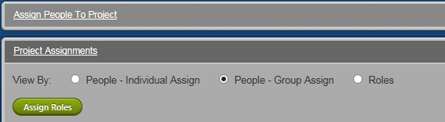

The Assign Roles button will appear after you select a checkbox
- Select the people you want to reassign, filtering the list, if needed.
- Click Assign Roles to open the Select Roles dialog.
- Select roles as needed, then click Assign Roles. All of the selected roles will be assigned to all of the people you selected on the previous page.

Key Events
In the Project Admin tab, the Key Events sub-tab allows you to manage all the milestones and actions that occur during a project. You can add court events (judicial actions, such as filing a Settlement Agreement, or setting a date for a preliminary approval meeting) and project events (GCG action, such as activating a Web site or doing an initial mailing) for your project.
Court events are simple calendar dates, but for an internal GCG event, you can track its Court mandated date, our internal target date for completing it, and the date the client wants it. You can check off individual events as completed and sort the list as of any date you want.
Practice using the Key Events tab:
- In the Project Admin tab, click Key Events.
- Click Add Court Event.
- Select any option from the Event Type drop-down.
- Select a time zone.
- The Court Mandated Date options reflect whether the date is a simple calendar date (Cal. Date) or a date based on relative date (Rel. Date). Select Rel. Date.
- In the Relative Date fields, set the number of days before or after an event you select from the Select An Occurrence drop-down. The system shows you the calculated date so you can confirm your choices.
- Let’s say that the action needs to occur before noon. From the Time drop-down, select 12:00 PM.
- Click Add Court Event.
- Now let’s define a deadline for receiving claim forms from potential claimants. Click Project Event.
- From the Event Type drop-down, select Claim-form deadline.
- The Deadline Condition field is an optional field that lets you define the conditions of the deadline is defined, such as the postmark of a letter instead of the date of receipt. Select Postmarked.
- The Timing Constraint field defines whether the event should occur on, before, or after the specified date. We want to accept as on-time claim forms received up to and on the date we’re going to set. Select On or before.
- Set the time zone.
- In the four date sections, define at least one calendar date and one relative date. All four dates are required, but you can set any of them to TBD or n/a if you don’t need them for the event.
- When you’re finished, click Add Key Event.
Confirm that your newly defined event appears in the Key Events page. In the future, these events will trigger alerts to your My Notification page.

Upload Key Documents
You can upload documents from your C: drive or from any network directory to which you have access.
Practice uploading a document:
- In the Project Admin tab, enter “COC” in the Project Code field.
- Click Search.
- Click Key Documents.
- In the Upload Another Document section, select Declaration from the Upload this document type drop-down.
- In the Name for the document field, enter “First Declaration.”
- From the Stage dropdown, select Draft.
- Click Browse to open Windows Explorer.
- Navigate to your Desktop and double-click the Generic_doc_Training.doc file. Confirm that the path for the file is showing in the Upload from this file field.
- To the right of the Browse button, click Upload.
Click to page 2 and confirm that the document now appears in the Already Uploaded Documents list.
Continue with the next chapter to learn how to create a claim entry form for your project.
Chapter
5
Claim Entry Forms
This chapter explains how to create a claim entry form in 20/20 and provides some technical context about working with the Systems team

Planning
Most new projects require a claim entry (CE) form in 20/20 so processors have a place to enter claim data. The CE form that you build in 20/20 starts with the draft of the claim form received from the client/Court. You might be able to simply re-create the form in 20/20 from that draft, but more often there are things that you need to add to the CE form to be able to capture certain the details for your project.
For example, when claim forms are submitted online, submitters can claim to have proof of purchase for 10 items, but the actual proof of purchase shows a different amount, say 4. To give processors a place to verify the proof of purchase, you might add a field to the CE form like this:
Proof of purchase matches request

Overview of the Form Creation Process
In general, the process of creating the CE form involves the following steps. We’ll go into more detail as we continue:
- Analyze the claim form draft from the client in anticipation of every possible scenario, and plan the CE form to get the results you need.
- Determine whether (and how) you’ll use the initial data load (IDL) to prepopulate the name and/or claim records in 20/20.
- Using the Claim Form Configurator, build the CE form in the production (PROD) environment of 20/20.
- Do the following three steps in any order:
We use two 20/20 environments: PROD is where “real” work is done. Changes in PROD impact live records. UAT is a copy of PROD that provides a sandbox for testing. Changes in UAT do not impact live data.
- Ask the Systems team to copy your CE form to the test (UAT) environment of 20/20.
- Ask the QA team to review and approve your CE form (in UAT or PROD), ensuring that the claim entry form meets requirements.
- (Optional) If your project needs a Website, after QA approves of the CE form, export it to a spreadsheet so the Systems team can build the Website.
- Work with the 2020 Team to create condition reasons for your project, then create tests in your UAT CE form.
- Promote your CE form in UAT and ask the Systems team to import some “pseudo claims” into UAT so you can experiment with the CE form and condition reasons.

We only copy from PROD to UAT, never the other way, so we avoid potentially contaminating the data in PROD.
- If something needs to be changed or added to the CE form, either add it in UAT and PROD, or add it only in PROD, then ask the Systems team to copy your CE form to UAT again.
- Repeat step 7 until you confirm that you’re getting the results you need.

Some Leads like to keep an instance of UAT open in its own IE tab so they can double-check whether issues they see in PROD are universal to 20/20 or unique to their project
- When everyone is happy with the CE form in UAT, update (manually) the form in PROD to mirror the one in UAT, then promote it. (This step doesn’t need to happen until the client needs to see something or when you’re ready to start receiving claim forms.)
- Processors can start using the CE form via the workflows in 20/20.
For a handy checklist of this information, see Appendix B.

Planning the Form
The biggest challenge when setting up a CE form is to figure out how to map familiar CLASS concepts into 20/20 when you don’t know the technicalities or the impact on the database. The following section is designed to demystify the process.
As you think about how to create your claim entry form in 20/20, ask yourself the following questions:

Requirements
What data needs to be gathered? What criteria must be satisfied for claimants to be paid?

See Appendix C for a worksheet that can help your planning
This information comes from case documentation and from the claim form draft provided by the client/Court, but also from your foresight into possible scenarios.
You want to make sure that the CE form captures whatever data is needed to determine completeness and eligibility. You also might want to include additional fields to capture something that’s not on the claim form, such as a field for a missing signature or field to capture that two options were selected instead of one.
Consider, too, the nature of the data you’ll need. For example, will you need to accommodate international addresses? If yes, will it suffice to use “99” as the country code for all non-U.S. addresses or will you need a specific code for each country? How will you transfer data from a Web form into your CE form, for example, are dates entered or selected from a drop-down? How many phone numbers will you need, and of what type (home/cell or day/night)?

Deficiencies
The challenge is to avoid discovering that critical information is missing downstream, while at the same time entering only necessary information, avoiding gather data that seems related, but in actuality, doesn’t affect the determination of eligibility or payout. Anticipate that some submitted data might be unnecessary. Ask good questions of the client to make sure that the claim entry form will produce the reportable data they need and expect.
What data, if missing, would make a claim ineligible or incomplete?

Functionality
Clearly establish the criteria for eligibility and completeness by carefully analyzing the parameters of the case. Consider not only conditions in the supporting docs that might trigger ineligibility/incompleteness, but also what might be missing.
What data type or functionality (text, date, money, whole number, pick from list, or yes/no) best suits each required data point?
As you plan your claim entry form, you’ll need to figure out how to express the data being gathered using one of the data types available in the CE form. (See Appendix D for a table that explains all the building blocks that are possible for a claim entry form.)
Consider, too, that validation tests differ per data type. (See Business Rules (aka If Tests) for more information.) Once the claim entry form is promoted, the data types of the fields in the form can’t be changed. If you discover that a field’s data type is wrong, you’ll have to completely delete the field, then replace it.

Limits
What date ranges and quantity boundaries are needed?
Consider whether any of the data needs to be driven or limited by ranges (with an upper and lower limit) or thresholds (a minimum or maximum that must be reached). Using ranges and thresholds helps reduce entry errors and allows you to set up automated tests for eligibility.
For example, you can set a rule that a transaction must occur between two dates. If documentation from a potential claimant proves that the date was out of range, 20/20 will change the status of that claim to Ineligible and include that claim in any reports about ineligible filings.

Defaults
What is the most common response for each data point?
If you anticipate that a field will tend to have a certain response, consider setting a default value for that field. Defaults are values that are pre-set to the response you anticipate will be the most common. Using defaults can save processing time if those values are wisely chosen.
For example, if the options for a field are Yes, No, and N/A, and you anticipate that the majority response will be No, you can set the field to show No as the default. As a result, processors won’t have to make a selection for that field most of the time. They can accept the default.

Usability
What additional controls/fields are needed online to record data from a submitted claim form?
Consider that additional fields and controls might be needed to convert the client/Court draft into a 20/20 CE form. Will potential claimants be able to complete the form themselves on the Web? If so, the Webpage can control and validate much of the data entry, such as limiting date ranges and requiring the completion of certain fields before the form can be saved.
Consider the following examples of how a Web page can impact a 20/20 form:
- A Web form might limit input to credit card purchases from January to March 2012. In the 20/20 claim entry form, instead of creating date fields for the purchases and adding a validation test, you can simply create a Yes | No field that confirms that the date was indeed valid.
- A Web form offers three options called Red, Blue, and Green. In the 20/20 claim entry form, you’ll need additional options, one each for Red, Blue, and Green, but probably also for All Selected and for None Selected.

Structure
How many pages are needed to make the most effective claim entry form?
Will a single-page claim entry form provide the best usability for processors, or will the form contain natural groupings of data that suggest that multiple pages will be more effective and make data entry easier?
Will the potential claimants submit their claims via the website?
If so, it’s possible to create a table in your CE form to accommodate some of that data, such as information about place of purchase, purchase date, and purchase amount. Work with the Systems team on the flow of information from the Website into your CE form.
Is a claim entry form even needed?
Not all projects require a claim entry form. For example, sometimes a project requires only a Notice of Pendency to inform claimants about the case and give them the opportunity to object or exclude themselves.
Are multiple instances of single field needed?
The basic name and address information is already mapped to the database in the CE form template. But if a project needs multiples of an element (such as more than one Phone field for home phone, work phone, and cell phone), you can easily add them.
How will you use the initial data load (IDL)?
Consider the following scenarios:
- If the IDL for your project contains only names and addresses (what the Systems team refers to as project party, formerly “NME”), you can most likely use the consumer template in the CFC right out of the box for your claim entry form. In this case, the IDL can be done before you create the CE form. When the IDL is imported, name records are automatically created for the project.
- If the IDL includes data that doesn’t have a home yet in the database, and you want to show that information as read-only in the claim record, you can customize the CE form with fields to accommodate that data. Then, when we do the IDL, data is prepopulated into claim records that are already associated with name records.
- Sometimes an IDL is completed before realizing that it contains data that needs to go into the claim records. In this case, work with the Systems team to pull that data into the claim entry form from the staging table, where the IDL is stored after import.
Will you need related name records?
Related name records are similar to name records, except they contain information specific to a non-claimant, who is somehow related to a claimant (such as a legal guardian, a contact, an attorney, parent, owner of an organization, etc.). If your case is one of the few that are impacted by people other than claimants, you might need to set up your project to include related name records.

Web Forms
With answers to these questions (or at least most of them), you’re ready to build your CE form.
How will information from a Web form work in 20/20?
If your project includes an online claim form, be aware of the limitations of the CE form in 20/20 as you design the online form.
- A Web form can take advantage of functionalities like requiring fields to be completed before the form can be saved—essentially preventing users from giving us empty data. But the CE form that you build in 20/20 cannot impose such restrictions.
- In a CE form, tests can be applied to only one field at a time. This limitation will impact how you build the CE form, often requiring multiple fields and tests instead of a single test that could be applied to multiple fields at the same time.
The relationship between Web forms and CE forms (created via the CFC tool) are as follows:
- To launch your Web form, your CE form must mirror your Web form field-for-field so data from your Web form has a place to be stored. Even though the Systems team hand-codes your Web form, they must use the actual database fields that you create in your CE form.
- After you promote your CE form and launch the Systems team launches the Web form, you can add fields in the CFC without worrying about breaking things in the online form. However, new fields added to your CE form will not be added to the Web form unless you engage the Systems team at 2020Support@.
- If you add an option to a button group or drop-down list in the CFC, you can expect the new option to be dynamically added to the Web form.
- You can change editable titles in your CE form, but you cannot delete fields. If you need to delete a field and create a new one, contact 2020Support@.
- If you change certain properties in the CFC, such as whether a field is required or whether the field uses defaults, those characteristics will also be updated in your Web form.
- As a general rule, as long as you’re using the CFC to make changes, you’re not going to break your online form.

Using the Claim Form Configuration Tool
The Claim Form Configuration (CFC) tool in 20/20 allows you to create CE forms that meet the specific requirements of each project. Several options for creating CE forms are available:

Securities projects can usually use the template right out of the box.

Consumer projects often need a modified template or a claim entry form created from scratch.
- Using templates for security projects, with and without option transactions
- Using a template for consumer projects
- Starting from scratch
  - Adding items manually, one by one
  - Uploading a spreadsheet
The tool also provides a preview or mockup of the form so you can get an idea of what the form will look like before it goes live.

About the Templates
The templates provided in the CFC already contain many of the commonly used fields, such as name and address. The templates also contain blank, pre-built tables that you can use for transactional data. Tables in the template for security projects are already set up for security cases.

Building the Form
Let’s take a quick tour of a template. To use the CFC, one of the following roles is required:
- Claim Form Configurator
- Ops Lead, Primary
- Ops Lead, Secondary
To promote a claim entry form to go live, the Claim Form Promoter role is required, regardless of whether you have any other the roles listed above.
Practice creating the shell for a new CE form:
- In the Claims tab, select your project from the Project drop-down.
- Click Claim Form Configuration in the left menu.
- Click New Claim Form.
- In the New Claim Form dialog box, enter the following:
- A title for your claim form
- Your first and last name
- From the Form Type drop-down, select Consumer.
- From the User Form Template drop-down, select Yes.
The options offered to you at this point are based on selections made during project setup (in the Case Related? field in the Project Admin tab). You’ll only be offered a securities template if your project was set up as a securities project.
It’s usually easier to remove unwanted fields from a template than to create a CE form from scratch, even if you have a simple case. See Appendix D for a chart of all the widgets you can put into a CE form.
- Click Create Claim Form.
The information you entered is now displayed in the Claim Form sub-tab of the CFC tool. You can see an approximate preview by clicking the Claim Form Preview tab. Now you’re ready to modify the CE form to meet the requirements of your project.

Each line in the table defines one entry field, header, or widget. For more information and definitions, see Appendix D. If you use a template, you can delete the fields you don’t need and add new ones.

Properties defines the field; Insert adds new line above the current line
Position of table column, when applicable
Behavior of the field; see definitions in App. D
The preset options in a drop-down field
Click the link to create a business rule (if test) for that field; shows the number of tests defined per field

Page no. in the form; line no. per page
Title you give to the field; edit via Properties
The database table associated with the field
The column name in the database table

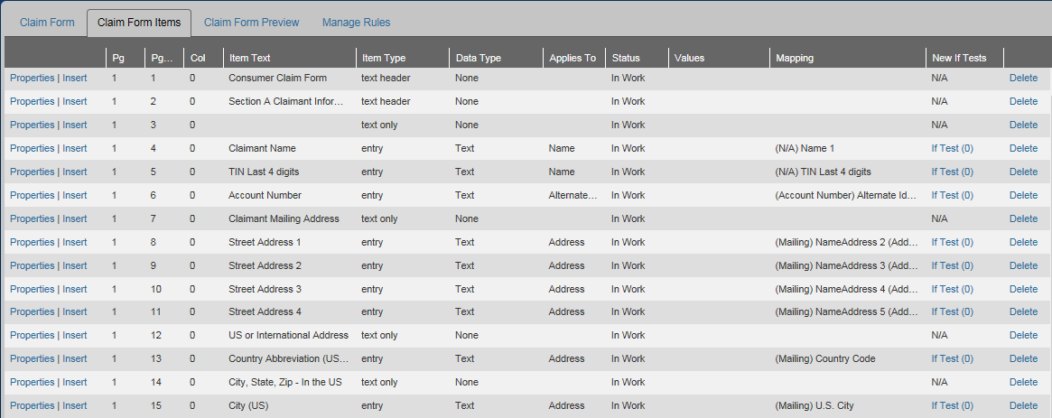

Headers and Spacers

Text Headers
The first line in the template defines a Text Header item, which inserts a horizontal banner at the top of the page, like this:
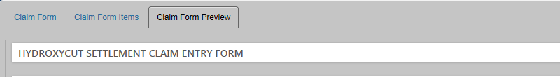
The template already has a couple of section headers, but you can modify them.
Practice editing a text header:
- Click the Claim Form Items tab.

The title of your first page can be the same as the title you entered in the New Claim Form page.
- In the first row, click Properties to open the page that lets you edit that row.
- In the Text field, change the name of the template to something like “Project XYZ Claim Form.”
- Notice that the New Page field is set to Yes. The first Text Header of every page of a claim form will be set to Yes.
- Click Save Edit Changes.
- In the breadcrumb at the top of the page, click Claim Form Items View to return to the Claim Form Items tab with the table.

Create Multiple Pages
Early in the process, figure out whether multiple pages will be needed for your project. If your project doesn’t require much data, you might decide to use a single page that won’t require much scrolling. But if your project requires a lot of data, and that data can be organized into logical groupings, consider creating multiple pages to make it easier for processors to navigate the form.
Processors will be able to see multiple links at the top of the CE form, like this:
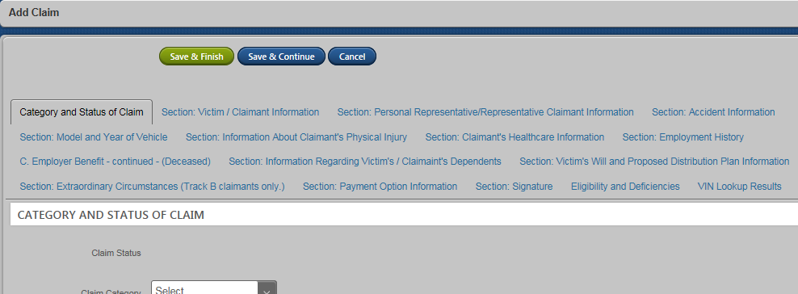
Clicking the links in a multi-page CE form makes it easier to go from page to page, especially in long forms.
Practice creating a page break:
- Click the Claim Form Preview tab, and scroll down to Section C. Let’s say we decide to make Section C its own page.
- Click the Claim Form Items tab.
- Locate line 32, which is a text header row called “Section C – Release, Signature, and Certification,” and click the Properties link for that row.
- In the New Page drop-down, select Yes.
- Click Save Edit Changes.
- In the breadcrumb at the top of the page, click Claim Form Items View to return to the Claim Form Items tab with the table.
- Click the Claim Form Preview tab, then scroll to the bottom. Notice that Section C is no longer there.
- At the bottom of the page, click the page navigator for the second page.
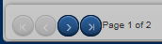
- You now have second page in your CE form. You can see the results in the Claim Form Items tab.
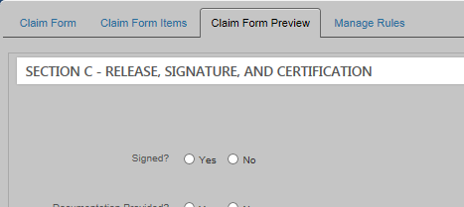
- In the breadcrumb at the top of the page, click Claim Form Items View to return to the Claim Form Items tab with the table.

Text Only Items (Spacers)
The Text Only item can be used to add an empty row (for padding) or to add a sub-title (similar to a Heading 2). For example, in the following claim entry form, two Text Only line item were added, the first for the extra row after Claimant Identification and the second to insert the title “Claimant Mailing Address.”
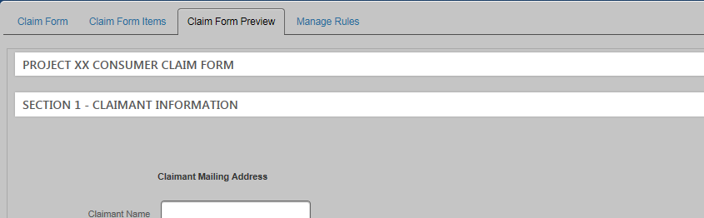
Text Only item without a title
Text Only item with a title
In the Claim Form Items view, those rows (rows 3 and 4) look like this. Notice that both items are listed in the Data Type column as “None.” This means that the item has no functionality. Instead, it’s a title or spacer.
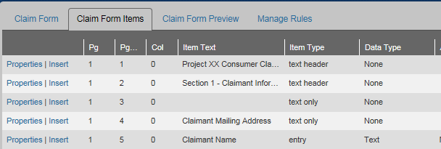

Practice adding a new Text Header, followed by a Text Only item:
- Click the Claim Form Items tab.
- In the Add Item drop-down, select Text Only.
- In the Text field, enter “Section D – Contract Details.”
- In the Text Type drop-down, select Text Header.
- In the New Page drop-down, select No.
- Click Save Changes.
- Click the Claim Form Items View breadcrumb to return to the Claim Form Items tab.
- In the Add Item drop-down, select Text Only.
- Make no changes, and simply click Save Changes to add a spacer row.
- In the breadcrumb at the top of the page, click Claim Form Items View to return to the Claim Form Items tab with the table.
- Click Claim Form Preview and go to the second page to see the new header and spacer rows that you just created.

Now you’re ready to explore the data entry fields.

Data Entry Fields

About Data Entry (Non-Table) Fields
The data entry fields allow you to enter, select an option, or select from a pre-populated list. The following widgets are available in the Add Item drop-down:
Add Item | Data Type | Usage | Example
Entry | Text * | Use for general data entry, for data that doesn’t fit well into any other type of field.
Entry | Whole Number | Use for general numeric fields. Inserts a picker (clicks up and down). Automatically inserts a four-place decimal. If you need something without decimals, use a Text item instead.
Entry | Decimal | Use for numeric fields that require decimals; automatically adds a four-place decimal. | 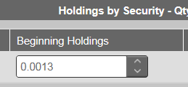
Entry | Date | Use to insert a calendar widget. Inserts a picker widget (to click up and down). Allows you to set a range of dates. | 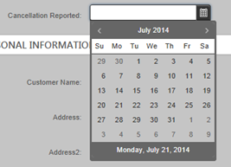
Entry | Money | Use for currency fields. Automatically inserts a four-place decimal and a dollar sign after you press Enter. | 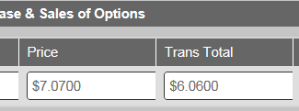
Checkbox | Boolean | Use a single box for a simple true|false response. Use a series of checkboxes to allow processors to select multiple items.
Drop-down list | Text | Use this when you want users to select only one item from a list of items; usually used when a list exceeds 3-4 options | 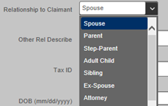
Button Group (radio buttons) | Text | Use when you want users to select only one option from two or more choices; usually no more than 3-4 options
 | * Memo fields function the same as Entry – Text fields, above, except that Memo fields allow multiple lines of text rather than just one.

For more information about what to consider while creating each type of field, see Appendix D. For descriptions of any of the fields in the Add Item page, see Appendix E.
Practice adding fields to the CE form:

Add a Number Field
- In the Claim Form Configuration tool, click the Claim Form Items tab.
- In the Add Item drop-down, select Entry.
- Use the following table to complete each field.

Field Name | Action
Item Status | Accept the default of In Work
Text | Enter “Number of Purchases”
Data Type | Select Whole Number
Lower Limit | Enter “0”
Upper Limit | Enter “999”
Max Entry Length | Accept the default
Field Width | Accept the default
Default Value | Accept the default of No
Required for Claim Entry | Accept the default of No
Mapping To | Accept the default of Name/Claim
Applies To | Accept the default of Claim
Visibility
Claim Entry | Accept the default of Editable
Claim Processing | Accept the default of Editable
Web Entry | Accept the default of View Only

For the Mapping To option, you’ll use the Name/Claim option most of the time. Use the Related Name option only if you’re defining a field that specifically applies to related name records. (Most projects don’t use related name records.)
- Click Save Changes. (If you click Save & Next here, you’ll open a new Add New Item page that lets you add another new Entry item.)
- Click the Claim Form Items View breadcrumb.
At the bottom of the Claim Form Items tab, the row for the new field should look like this:
In the Claim Form Preview, the new field should look like this:
Take a moment to explore the Applies To, Map To Type, and Map To Field drop-downs with the help of Appendix F. Note that the data structure is tied to specific fields in the template. For these exercises, we’re simply accepting the defaults for these fields, but if you need to modify the template or add new fields, the information in the appendix could be very helpful.

Add a Checkbox
- Click the Claim Form Items tab.
- In the Add Item drop-down, select Checkbox.
- Use the following table to complete each field.

Field Name | Action
Item Status | Accept the default of In Work
Text | Enter “Language Verified”
Data Type | Accept the default of Boolean
Default Value | Accept the default of No
Required for Claim Entry | Select Yes (Based on this setting, processors will get an error message if the field is left blank when they click Save.)
Mapping To | Accept the default of Name/Claim
Applies To | Accept the default of Claim
Visibility
Claim Entry | Accept the default of Editable
Claim Processing | Accept the default of Editable
Web Entry | Accept the default of View Only

- Click Save Changes.
- Click the Claim Form Items View breadcrumb.
At the bottom of the Claim Form Items tab, the row for the new field should look like this:
In the Claim Form Preview, the new field should look like this:

Add a Drop-down Field
We’ll add a drop-down field next, but let’s say that we want to have it show up before the “Number of Purchases” field that we already created. We could create it, then move it, but it’s easier to just insert it, if you can.
- In the Claim Form Items tab, click the Insert link for the Number of Purchases row.
- In the Insert Item drop-down, and select Drop-down.
- Click OK.
- Use the following table to complete each field.
Field Name | Action
Item Status | Accept the default of In Work
Text | Enter “Proof of Employment”
Data Type | Accept the default of Text
Default Value | Select Yes
(unnamed field that appears to the right) | Enter “W-2”  (Anticipating that the majority of the submissions will include proof of employment)
Required for Claim Entry | Select Yes  (Based on this setting, processors will get an error message if the field is left blank when they click Save.)
List Item #1 | Enter “Tax Forms”
List Item #2 | Enter “W-2” (then click Add List Item)
List Item #3 | Enter “None” (then click Add List Item)
List Item #4 | Enter “Other”
Mapping To | Accept the default of Name/Claim
Applies To | Accept the default of Claim
Visibility
Claim Entry | Accept the default of Editable
Claim Processing | Accept the default of Editable
Web Entry | Accept the default of View Only
Assuming that proof of employment is required for the payout, the inclusion of the “None” option will allow you to set up a test to set the status of a claim to Ineligible when a claim lacks the required documentation.
- Click Save Changes.
- Click the Claim Form Items View breadcrumb.
In the Claim Form Items tab, the row for the new field should look like this:
In the Claim Form Preview, the new field should look like this:
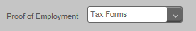
Notice that the default is showing “Tax Forms” instead of what we asked for, “W-2.” The preview is able to show fields as you create them, but they won’t always be fully functional. In this case, the field will accurately default to “W-2” after the form is promoted, even though the preview shows something else.

Add a Button Group
- In the Add Item drop-down, select Button Group.
Field Name | Action
Item Status | Accept the default of In Work
Text | Enter “Payment Preference”
Data Type | Accept the default of Text
Default Value | Accept the default of No
Required for Claim Entry | Accept the default of No
Button Item #1 | Enter “Check”
Button Item #2 | Enter “Direct Deposit” (then click Add Button Item)
Button Item #3 | Enter “None Selected” (then click Add Button Item)
Button Item #4 | Enter “Both Selected”
Mapping To | Accept the default of Name/Claim
Applies To | Accept the default of Claim
Visibility
Claim Entry | Accept the default of Editable
Claim Processing | Accept the default of Editable
Web Entry | Accept the default of View Only
- Click Save Changes.
- Click the Claim Form Items View breadcrumb.
At the bottom of the Claim Form Items tab, the row for the new field should look like this:
In the Claim Form Preview, the new field should look like this:

Tables
Use tables in your CE form to organize and consolidate related or repeated data.
Tables can be built column by column, but the templates contain pre-constructed tables that you can use as-is or modify as needed. All security projects use the tables from the template to capture transactional data. Consumer projects sometimes benefit from tables when they involve purchasing data.
Each table column can be formatted with the same Entry, Checkbox, Drop-down, or Button Group fields that are described above for non-table fields, except that memos can’t be used in tables.
The Add New Table Item page is where you to create the structure of the table by adding columns, but after you create the table shell you need to further define each column in its own Properties page.

Build a Table Shell
Practice building a table shell from scratch:
- In the Claim Form Configuration tool, click the Claim Form Items tab.
- In the Add Item drop-down, select Table, then do the following:
Field Name | Action
Item Status | Accept the default of In Work
Text | Enter “Purchase Information”

By default, the page opens ready to define the first column (notice the tab called New Column, which represents the first column in the table). We’ll rename it and define what kind of data it will hold, then add several more columns to the right.
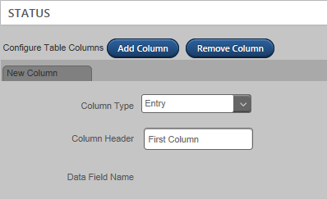
- Do the following:

Field Name | Action
Column Type | Accept the default of Entry
Column Header | Enter “Place of Purchase” as the title for the column
 | Click Add Column
Column Type | Select Drop-down
Column Header | Enter “Name of Product” as the title for the second column
 | Click Add Column
Column Type | Select Entry
Column Header | Enter “Date of Purchase” as the title for the third column
 | Click Add Column
Column Type | Select Entry
Column Header | Enter “Total Paid” as the title of the fourth column
 | Click Add Column
Column Type | Select Button Group
Column Header | Enter “Payment Type” as the title for the fifth column
 | Click Add Column
Column Type | Select Checkbox
Column Header | Enter “Proof of Purchase” as the title for the sixth column
Visibility
Claim Entry | Accept the default of Editable
Claim Processing | Accept the default of Editable
Web Entry | Accept the default of View Only

The Visibility fields at this level are for setting the entire table to be editable, invisible, or view-only during the Claim Entry and Claim Processing workflows. The Web Entry setting applies to online forms, when applicable.
Individual columns also have their own visibility settings, via the Properties links in the Claim Form Items tab. Using the Properties settings, you can hide specific columns during the workflows or in the CE form online.
- Click Save Changes.
- Click the Claim Form Items View breadcrumb. The table should look like this (with different row numbers):
- Click Claim Form Preview tab and go to the second page to see the table. The preview should look like this:
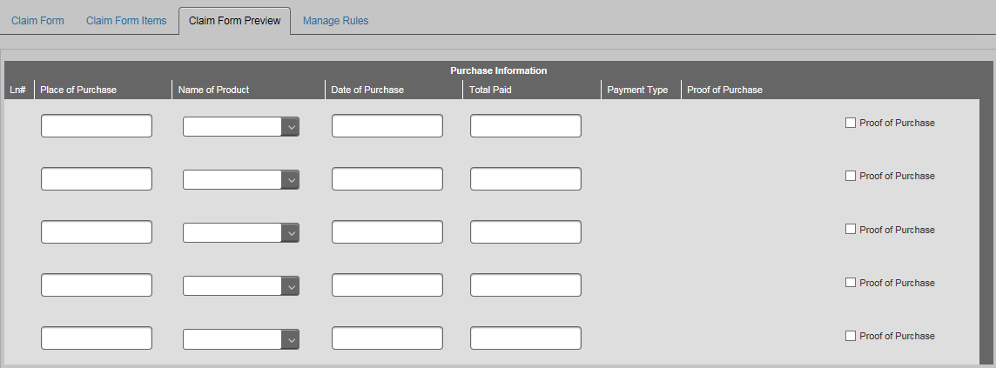

We’ve filled our table with columns but now the columns need to be further defined. (Notice that the button group doesn’t show up yet). Next, we’ll set the properties of each column.

Set Column Properties
- Click the Claim Form Items tab.
- In the row for Place of Purchase, click Properties.
- For this first column, let’s assume that we just want a simple free-form data entry field that’s visible during the workflows. In the Edit Entry Text Item page, define the column as follows:

Field Name | Action
Item Status | Accept the default of In Work
Text | Accept the default
Data Field Name | (This is the name of the database column that will hold all the data entered into the CE form)
Data Type | Accept the default of Text
Max Entry Length | Accept the default
Field Width | Accept the default
Default Value | Accept the default of No
Required for Claim Entry | Select Yes
Applies To | Accept the default of Claim Detail
Visibility
Claim Entry | Accept the default of Editable
Claim Processing | Accept the default of Editable
Web Entry | Accept the default of View Only

- Click Save Edit Changes.
- Click the Claim Form Items View breadcrumb.
- In the row for Name of Product, click Properties.

For this second column, let’s assume that we want to define the list of products involved in the settlement, and that we want the field to be required during the workflows. In the Edit Drop-down page, define the column as follows:

Field Name | Action
Item Status | Accept the default of In Work
Text | Accept the default
Data Field Name | (This is the name of the database column that will hold all the data entered into the CE form)
Data Type | Accept the default of Text
Default Value | Accept the default of No
Required for Claim Entry | Select Yes
 | Click Add List Item
List Item #1 | Enter “Product 1”
List Item #2 | Enter “Product 2”
List Item #3 | Enter “Product 3”
List Item #4 | Enter “Other”
List Item #5 | Enter “Blank”
Applies To | Accept the default of Claim Detail
Visibility
Claim Entry | Accept the default of Editable
Claim Processing | Accept the default of Editable
Web Entry | Accept the default of View Only
- Click Save Edit Changes.
- Click the Claim Form Items View breadcrumb.
- In the row for Date of Purchase, click Properties.
For this third column, let’s format a calendar widget. It won’t be required during the workflows. In the Edit Entry Text page, define the column as follows:

Field Name | Action
Item Status | Accept the default of In Work
Text | Accept the default
Data Field Name | (This is the name of the database column that will hold all the data entered into the CE form)
Data Type | Select Date
Lower Bound | Enter “01/01/2013”
Upper Bound | Enter “12/31/2014”
Max Entry Length | Accept the default
Field Width | Accept the default
Default Value | Accept the default of No
Required for Claim Entry | Accept the default of No
Applies To | Accept the default of Claim Detail
Visibility
Claim Entry | Accept the default of Editable
Claim Processing | Accept the default of Editable
Web Entry | Accept the default of View Only

- Click Save Edit Changes.
- Click the Claim Form Items View breadcrumb.
- In the row for Total Paid, click Properties.
For this fourth column, let’s set it to be a money field. In the Edit Entry Text Item page, define the column as follows:

Field Name | Action
Item Status | Accept the default of In Work
Text | Accept the default
Data Field Name | (This is the name of the database column that will hold all the data entered into the CE form)
Data Type | Select Money
Lower Bound | Enter “0”
Upper Bound | Enter “50.00”
Max Entry Length | Accept the default
Field Width | Accept the default
Default Value | Accept the default of No
Required for Claim Entry | Accept the default of No
 | Click Add List Item
Applies To | Accept the default of Claim Detail
Visibility
Claim Entry | Accept the default of Editable
Claim Processing | Accept the default of Editable
Web Entry | Accept the default of View Only

- Click Save Edit Changes.
- Click the Claim Form Items View breadcrumb.
- In the row for Payment Type, click Properties.
For this fifth column, we’ll define a set of radio buttons with a default value of “AMEX”. In the Edit Button Group List page, define the column as follows:
Field Name | Action
Item Status | Accept the default of In Work
Text | Accept the default
Data Type | Accept the default
Default Value | Select Yes
(unnamed field) | Enter “AMEX”
Required for Claim Entry | Select No
 | Click Add Button Item
List Item #1 | Enter “MasterCard”
 | Click Add Button Item
List Item #2 | Enter “AMEX”
 | Click Add Button Item
List Item #3 | Enter “Discover”
 | Click Add Button Item
List Item #4 | Enter “Other”
 | Click Add Button Item
List Item #5 | Enter “Missing”
Mapping To | Accept the default of Name/Claim
Applies To | Accept the default of Claim Details
Visibility
Claim Entry | Select Invisible
Claim Processing | Accept the default of Editable
Web Entry | Accept the default of View Only

- Click Save Edit Changes.
- Click the Claim Form Items View breadcrumb.
- In the row for Proof of Purchase, click Properties.
For this sixth column, we’ll further define a checkbox to verify whether proof of purchase was provided. In the Edit Checkbox Item page, define the column as follows:
Field Name | Action
Item Status | Accept the default of In Work
Text | Accept the default
Data Type | Accept the default of Boolean
Default Value | Accept the default of No
Required for Claim Entry | Accept the default of No
Mapping To | Accept the default of Name/Claim
Applies To | Accept the default of Claim Details
Visibility
Claim Entry | Select Invisible
Claim Processing | Accept the default of Editable
Web Entry | Accept the default of View Only

- Click Save Edit Changes.
- Click the Claim Form Items View breadcrumb.
Notice that the table now looks like this, with all of the options we created now showing up in the Values column.
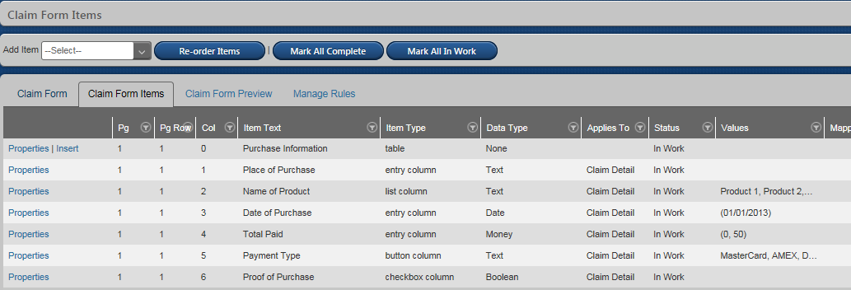
In the Claim Form Preview tab, all of the fields are now functional.
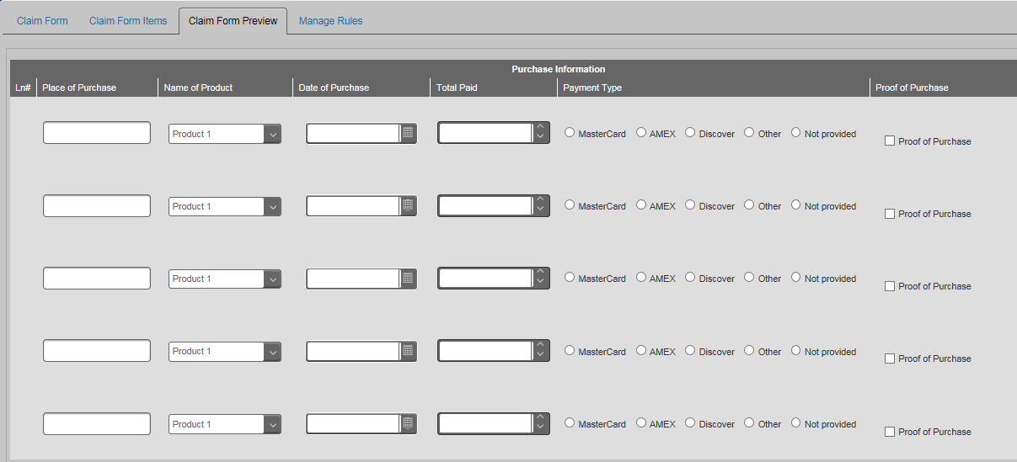
We’re now ready to set up some business rules in the CE form we just created.

Business Rules (aka If Tests)
The Claim Form Configuration Tool in 20/20 allows you to define business rules on specific fields in your CE form. If a rule is triggered when a record is saved, the status of the record is automatically set to Ineligible, Incomplete, No Further Action, etc., depending on how the rule is defined.
In general, you can set up rules based on the following:
- A value is missing/present
- A value is true/false
- A value is too low/too high
- A value is out-of-range/in-range
- A value matches (is equal to) a defined value
You can build any number of business rules into a CE form, and multiple rules can be applied to a single field; however, we can’t yet create multi-field tests, such as checking answers in multiple fields with a single test. This is important to remember as you “translate” a Web form into a 20/20 CE form.
For an example of an item that has multiple tests already built into the template, look at line 30 for “Documentation.” In the preview, you can see that the Documentation drop-down offers six options. We can see from the If Test page that there are rules set for three of those options. So if any of those options are selected for that field, the condition of the claim will be set to Incomplete upon saving the claim.
Tests are not dependent on whether the field is promoted. Tests can be created before the CE is promoted or after promotion.
Let’s say that we want to add a test that will flag claims as Incomplete if the potential claimant fails to identify a product that qualifies for reimbursement. To accomplish this, we need to create a rule attached to the Blank option in the Name of Product field that we created previously.
Practice creating a test:
- Go to Claim Form Configuration > Claim Form Items.
- In the Name of Product row, click the If Text (0) link on the far right.
- Click Add.
- In the IF drop-down, select If Value is Missing.
- In the Condition drop-down, select Incomplete.
- In the Reason drop-down, select Documentation is inadequate.
- Click Save.
- Press F5.
- On the far right, click the Applies To All link.
Now we need to consider whether to apply the test to all input channels, or only to select ones. In the Set Test Applicability dialog, you can turn a test on/off based on how we receive claims for your project. For now, let’s assume your project has a Web site, and you’ve designed it to require the completion of the Name of Product field online before the user can continue. This means that claims submitted via the Web site never need the test we just created.
- In the Web Site drop-down, select No.
- Click Save.
- Click the Claim Form Items View link in the breadcrumb.
Now you have a trigger (test) that will apply a specific condition (Incomplete) under a specific circumstance (the value is missing in the Name of Product field). You can click the Manage Rules tab to see all the tests set up so far for the CE form.

Create a New Condition-Reason
It’s prudent to use the predefined condition-reasons whenever possible, but there will be times when you can’t avoid creating a new one. The general rules for creating a new condition-reason is that we want to be careful to avoid creating redundant codes, while creating new ones that thoughtfully target specific deficiencies.
Earlier, we created a Payment Type column that will identify how the product was purchased. Let’s say that the case requires us to flag claims as Incomplete whenever the payment type is missing. Go to Claims > Map Condition Reason and review the list of already defined condition-reasons.
Practice creating a new condition-reason:
- Open a new instance of 20/20 in a new tab.
- Go to Claims > [select your project] > Map Condition Reason.
- Search the Map Condition Reason list to ensure that the “Missing Payment Type” (or anything like it) doesn’t already exist.
While there’s one for Incomplete because of missing documentation, we determine that the case requires a special callout related to payment type. In this case, we’ll need to create a new condition-reason.
- Go to http://2020testint/GCG.universalmaintenanceui.com. (Currently, we use a companion application inside 20/20 called the Universal Maintenance Tool [UMT]). (If you are unable to open the tool, contact 2020Support@gcginc.com.)
- From the Database drop-down, select PSD. (When the screen flashes, it’s ready.)
- From the Project Code drop-down, select your project.
- From the Table Name drop-down, select Business Object Condition Reason Code.
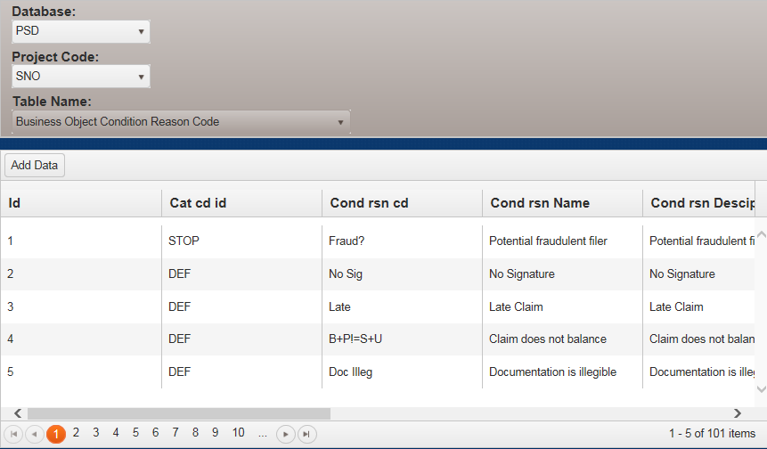
- Click Add Data to open the Insert Data dialog box.
- From the Cat cd id drop-down, select INL.
The conditions are listed as:
- DEF = Deficiency/Incomplete
- INL = Ineligible
- INFO = Information
- STOP = No Further Action
- NDR = No Doc Review
- YDR = (don’t use)
- ADDR = Address Correction

- In the Cond rsn cd field, enter “No pymnt type”. (This field is an abbreviated version of the name you give to the condition-reason, up to 15 characters, including spaces).
- In the Cond rsn Name field, enter “Missing payment type,” the full name for the condition-reason.
- In the Cond rsn Description field, enter “Missing payment type” again as a description.
- Set Is rslv ind to True because it’s possible to resolve this condition.
- Click Save.
The new item appears in the table (press F5 if needed). Note that you can edit and delete using the buttons to the far right (scrolling).
Now we need to tell the system to apply the test to a specific part of a claim record by mapping the condition-reason.

Mapping Condition-Reasons
The purpose of the Map Condition Reason table is to let you apply a condition-reason to one or more sections of information in a claim. We covered the following data structure earlier, but in the context of the Map Condition Reasons page, consider the following:
- Name – Select this column if you created a test on the Name, Tax ID (TIN), or TIN Last 4 digits fields in your CE form. Use it, for example, if you created a test to set the record to NFA if the name creates a Watch List hit.
- Address – Select this column if you created a test on the address fields (NameAddress 1-5, City, State, Zip, Country Code, and international address data). Use it, for example, if you created a test to set a record to Ineligible if the state code is ineligible.
- Phone – Select this column if you created a test on any of the phone number fields. Use it, for example, if you created a test to set a record to Ineligible if a phone number is invalid per the terms of the case.
- Email – Select this column if you created a test on an email address. Use it, for example, if you created a test to set a record to Incomplete if a required email address is missing.
- Alternate ID – Select this column if you created a test on the Alternate ID field. Use it, for example, if you created a test to set a record to Incomplete if a required account number is missing.
- Clm Detail – Select this column if you created a test for any of the transactional information in tables for a non-security project. Use it, for example, if you created a test to set a claim transaction to Ineligible if a purchase date falls outside of the class period.
- Claim – Select this column if you created a test that doesn’t apply to contact information or transactional data. Use it, for example, if you created a test to set a record to Incomplete if a signature is missing.
- Security – Select this column if you created a test for any of the transactional information (security holding) in the tables of a security claim.
Condition-reasons can be applied to more than one column. For example, we have a pre-defined condition-reason called Documentation is inadequate that is set for the Claim, Clm Detail, and Security columns. If you create a test using this condition-reason, a claim will be labeled as Incomplete if information is missing in any of those three sections of the claim.

Practice mapping the new condition-reason:
- Go back to the IE tab for your project (the Map Condition Reasons page), and press F5 to refresh the data.
Notice that the condition-reasons are already mapped to specific columns. If you use an existing condition-reason, you can expect that they will be applied without having to do any additional mapping. You can select additional columns for any condition-reason if you want to apply it to multiple sections in your CE form. Simply double-click to apply a new check mark in any blank column.

The “[E]” simply designates that a column is editable.
- Find the Missing Payment Type condition-reason you created at the end of the list (or search for it via the drop-down filter in the table header.)
- Click in the Clm Detail [E] column for that row. (Use Clm Detail instead of Claim for any data that lives in a transaction table.)
- Click Save Changes. Now we need to return to the CE form to set the trigger.
Next, you need to create a test in your CE form to trigger the application of the new condition-reason:
- Click the If Test (0) link for the Payment Type row.
- Click Add.
- In the IF drop-down, select If Value is Missing.
- In the Condition drop-down, select Incomplete.
- In the Reason drop-down, select Missing Payment Type.
- Click Save.
- Press F5.
- On the far right, click the Applies To All link.
- In the Web Site drop-down, select No.
- Click Save.
- Click the Claim Form Items View link in the breadcrumb.
Now let’s promote the CE form.

Promoting the CE Form
Each row of the CE form has its own status: In Work, Complete, or Promoted. The status determines whether the row is in progress, ready to go live, or live.

Status
The definition for each status:
- In Work means that the field is still being worked on:
  - It is not yet visible to users
  - It is editable
  - It can be deleted
  - If tests, if present, can be updated/changed
  - In Work items are never promoted
  - Complete items can be promoted while In Work items remain unchanged
- Complete means that the form designer is ready to promote the item:
  - The item is not yet visible to users
  - If changes need to be made, switch the item back to In Work.
  - Tests, if present, can still be updated/changed
  - Can’t delete in this state, but change back to In Work for deletion
  - Only Complete items can be promoted (go live)
- Promoted means that the field is live (the visibility of an individual field for users depends on the Visibility settings in the Properties settings):
  - Promoted items cannot be deleted
  - Only the following changes are allowed:
- Add a button or list item
- Change the label
- Change the visibility setting
- Move the item
- Change the order of buttons/list items
  - Tests can only be voided from the CE, then replaced with a new test.
After promoting your CE form, if you replace a test or add a new one, consider whether claims have been processed and condition-reasons have already been applied. You can void the test only (leaving as is any condition-reasons applied to claims) or void both the test and any applied condition-reasons.
Next, the new test needs to be manually run against all processed claims via Claims > [select project] >Evaluate Claim Tests. Select an entry method, then click Create List. The status of all affected claims will be updated based on the new test.

Getting Ready for Promotion
As you finish defining the fields, you can change the status manually (from In Work to Complete) in each item as you go, or change the status for all items in the entire form by clicking Mark All Complete at the top of the page. Only items marked with the Complete status go live when the CE form is promoted.
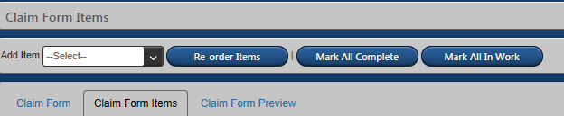

Promoting the Form
The Claim Form Promoter role is the only role that makes the Claim Form Promotion menu item appear so the CE form can be promoted. The form must be promoted before it can be viewed and used by processors.
Even after a CE form is promoted, you can add new fields and make the changes listed under the Promoted bullet in the Status section, above.
Practice promoting a CE form (only the Complete items):
- In the Claim Form Items table, click Mark All Complete at the top of the page.
- In the left menu, click Claim Form Promotion.
Clear Cache – Click this button after making cosmetic changes to your CE form, such as changing a label, adding an if test, or changing the visibility setting.
Promote Claim Form – Click this button when you’ve added new fields to your CE form. Clicking this button automatically clears the cache.
- Select the CE form from the Claim Form drop-down list if it isn’t already selected.
- Click Promote Claim Form.
- In the Modify Script section that appears at the bottom of the page, click the Execute Script link. Do NOT modify the script in this section.
Your CE form is promoted and ready for use.

Changes After Promotion
After you promote a CE form, certain changes can still be made:
- Edit field titles
- Add buttons and list items
- Reorder table columns and fields
- Remove buttons and list items as long as they don’t have associated tests
- Make a field required or remove the requirement
- Change the visibility of a field
- Add new fields, new if tests, and new tables
The following changes are not allowed:
- Change the data type of a field
- Remove a button or list item when a test has been applied
- Delete fields (but you can make them invisible)
- Remove table columns (but you can make them invisible)

Verify Condition-Reasons are Applied
When a business rule is broken when a claim record is saved, a yellow flag in the claim record alerts you to the issue. You can see the test by hovering over the flag or by looking in the expandable Condition-Reasons section.
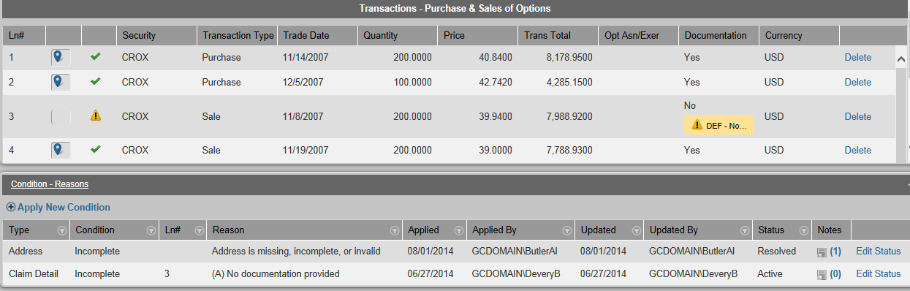
We can’t confirm that our new condition-reason and test are working because our project has no claims yet, but let’s create a claim form in another project that will trigger similar tests.
Practice confirming the application of a condition-reason:
- From the Claims tab, select project RDB, then click Add Claim.
- In the Claimant Name field, type your name.
- In the Editable Claim Details table, click Add Row.
- In the Choose Your Settlement Benefit button group, select Blank.
- In the If you selected free products… button group, select Blank.
- In the Signed button group, select Yes.
- In the Printed Name Provided button group, select No.
- Click Save & Finish.
- In the toolbar, click the Apply Conditions and Process link.
- Notice that the claim record is now marked Incomplete, the yellow flag shows the deficiency, and the Condition-Reasons section shows the condition-reason that was applied.
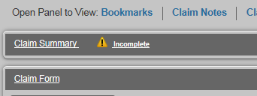
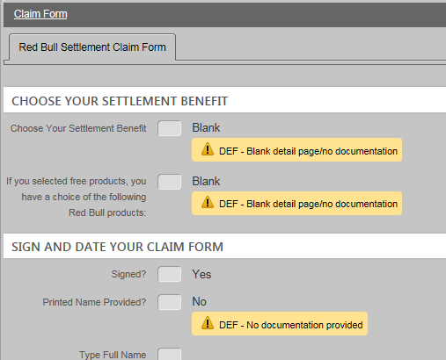
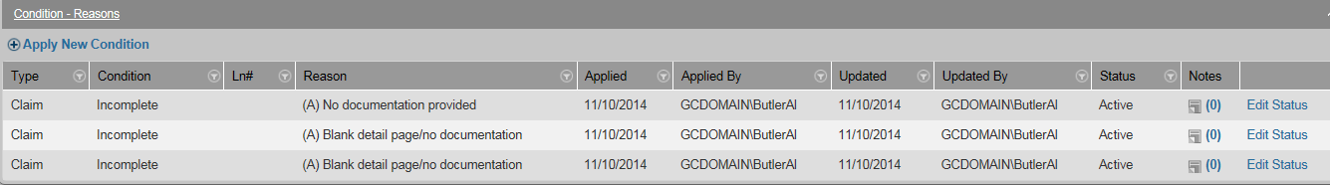
Condition-reasons can also be manually added to individual name records:
- Go to Claims > [select project] > Name/Claim Search and find/open the name record you want.
- In the Identity Details section of the name record, click Apply New Condition.
- In the Apply New Condition dialog box, select a condition category and reason from the drop-downs.
- (Optional) Add a note to explain the reason for the new condition-reason.
- Click Apply Condition.
There are several reports already created in the Reports tab for condition-reasons. Search on “condition” in the Reporting tab for a list of related reports available for your project.

This page is intentionally blank.

Appendix
A
Workflow Descriptions
White rows are processor tasks; blue rows are lead/supervisor tasks; green rows are QA tasks

Claim Entry Workflow
Available to Me | Assigned to Me | Role | Description | Next Step
Claim Entry - Ready for Assignment (Formerly, “Form ID”) | Claim Entry - Assignment in Progress | Claims Entry | Assign a submitted claim form (image) to a name record  Possibly assign an image to a claim record if a duplicate claim record exists and you are allowed to do such assignments | The next available Claim Entry – Ready for Assignment task opens after any of these:  - If completed, the doc goes to Claim Entry – Ready for Processing.  - If escalated, goes to Claim Entry – Lead Assignment.  - If skipped, goes to Claim Entry – Ready for Processing.  - If reassigned, remains in Claim Entry - Ready for Assignment.
Claim Entry – Lead Assignment | Claim Entry - Lead Assign In Progress | Claim Supervisor | Confirm/correct the assignment done by the processor | - If image is junk (cannot be assigned), and Complete Without Assignment is clicked, the image is permanently removed from the queue and the item is considered finished.  - If completed, goes to Claim Entry – Lead Processing.  - If reassigned to another Lead, remains in Claim Entry – Lead Assignment.
Claim Entry – Ready for Processing | Claim Entry - Claim Form Assignment | Claims Processor | Enter data from the submitted claim form (image) into 2020  Enter transactional data from the supporting docs  Confirm existence of supporting docs and signature  A claim record is created upon save, if needed | The next available Claim Entry – Ready for Processing task opens after all of these:  - If completed, goes to Claim Entry Review – Ready for Review.  - If escalated, goes to Claim Entry – Lead Processing.  - If reassigned, remains in Claim Entry – Ready for Processing.
Claim Entry - Lead Processing | Claim Entry - Lead Claim Assignment | Claim Supervisor | Confirm/correct the data entry done by the processor | - If completed, goes to Claim Entry Review – Ready for Review.  - If completed, exits the workflow.  - If reassigned to another Lead, remains in Claim Entry - Lead Processing.

QA for Claim Entry Workflow
Available to Me | Assigned to Me | Role | Description | Next Step
Claim Entry Review – Ready for Review | Claim Entry Review – Processing Review | Claim Entry QA | Review the data entry done by the processor during the Claim Entry workflow, then do one of the following:  Approve and complete processing  Reject and return the work item to the original claim entry processor for rework | - If completed, goes to the Available pool as a Claim Processing – Ready to Process  - If escalated to processor’s Lead, goes to Claim Entry Review – Lead Rework.  - If reassigned to another QA reviewer, remains in Claim Entry Review – Ready for Review.
- | Claim Entry Review – Processor Rework | Claims Entry | Work item returned for rework shows up in the processor’s Assigned to Me list  Update issues found during the QA review, then return to QA reviewer  Escalate to Lead if needed | - If completed, goes to Claim Entry Review – Ready for Review.  - If escalated, goes to Claim Entry Review - Lead Rework.
Claim Entry Review - Lead Rework | Claim Entry Review – Lead Rework In Progress | Claim Supervisor | Reprocess data from Claim Entry that needs supervisor attention | - If completed, goes to Claim Processing - Ready to Process.  - If reassigned to another Lead, remains in Claim Entry Review - Lead Rework.

Claim Processing Workflow (formerly, “doc review”)
Available to Me | Assigned to Me | Role | Description | Next Step
Claim Processing - Ready to Process | Claim Processing – Document Review In Process | Claims Processor | Review the data entered into claim record during the Claim Entry workflow  Determine whether the supporting docs in 2020 is consistent with project protocol  Use bookmarks to connect data points in the supporting docs to the claim record | - If completed, goes to Claim Processing Review - Ready for Review.  - If escalated, goes to Claim Processing – Claims Supervisor Processing.  - If reassigned, remains in Claim Processing - Ready to Process.
Claim Processing – Claims Supervisor Processing | Claim Processing – Claims Super Review In Process | Claim Supervisor | Ensure that the work done by the processor is correct  Deal with special situations | - If completed, goes to Claim Processing Review - Ready for Review.  - If reassigned to another Lead, remains in Claim Processing – Claims Supervisor Processing.

Available to Me | Assigned to Me | Role | Description | Next Step
Claim Processing Review - Ready for Review | Claim Processing Review - Processing Review | Claims Process QA | Review the data entry done by the processor during the Claim Processing workflow, then do one of the following:  Approve and complete processing  Reject and return the work item to the original claim processing processor for rework
 | Claim Processing Review - Processor Rework | Claims Processor | Work item returned for rework shows up in the processor’s Assigned to Me list  Update issues found during the QA review, then return to QA reviewer  Escalate to Lead if needed
Claim Processing Review - Lead Rework | Claim Processing Review - Lead Rework In Progress | Claim Supervisor | Reprocess data from Claim Processing that needs supervisor attention

Deficiency Processing and Review Workflows
Available to Me | Assigned to Me | Role | Description | Next Step
Deficiency Processing - Ready for Assignment | Deficiency Processing - Assignment in Progress | Claim Processor | Assign a deficiency response to a name record or claim record
Deficiency Processing – Lead Assignment | Deficiency Processing - Lead Assign In Progress | Lead | Confirm/correct the assignment and the info entered by the processor
Deficiency Processing - Ready for Processing | Deficiency Processing - Deficiency Assignment | Claim Processor | Enter deficiency data from the potential claimant in support of a previously processed claim
Deficiency Processing – Lead Processing | Deficiency Processing - Lead Deficiency Assignment | Lead | Confirm/correct the data entry done by the processor
Deficiency Review - Ready for Review | Deficiency Review – Processing Review | Claim Process QA | Review, then approve or reject the deficiency data done by the processor during the Deficiency Processing workflow

Available to Me | Assigned to Me | Role | Description | Next Step
 | Deficiency Review – Processor Rework | Claims Processor | QA returns the work item to the original claim entry processor for rework; work item shows up in the processor’s Assigned to Me pane; update issues found during the Deficiency Processing Review workflow, then return to QA reviewer; escalate to Lead if needed
Deficiency Review - Lead Rework | Deficiency Review – Lead Rework In Progress | Claim Supervisor | QA reviewer escalates the item to the processor’s Lead, who reprocesses data from Deficiency Processing that needs supervisor attention

Jetvision Processing New/Review Workflows
Available to Me | Assigned to Me | Role | Description | Next Step
Jetvision Processing - Ready for Assignment | Jetvision Processing – Assignment in Progress | Return Mail Processor | Assign an address correction or returned mail to a name record; the barcode is illegible
Jetvision Processing - Ready for Processing | Jetvision Processing – Jetvision Assignment |  | Barcode is legible; update the mail item status and address associated with the name record; if undeliverable, process accordingly
Jetvision Processing – Lead Assignment | Jetvision Processing – Lead Assign In Progress | Inbound Lead | Assign an address correction or returned mail to a name record
Jetvision Processing - Lead Processing | Jetvision Processing – Jetvision Lead Assignment |  | Update the mail item status and address associated with the name record; if undeliverable, process accordingly
Jetvision Review - Ready for Review | Jetvision Review – Jetvision Review | Reviewer (QA) | Confirm the updates made by the processor during the Jetvision Processing New workflow
 | Jetvision Review – Processor Rework | Return Mail Processor | Update issues found during Jetvision Review
Jetvision Review - Lead Rework | Jetvision Review – Lead Rework In Progress | Inbound Lead | Reprocess Jetvision Processing New items that need supervisor attention

Admin Mail Workflow
Available to Me | Assigned to Me | Role | Description | Next Step
Admin Mail – Ready for Assignment | Admin Mail – Assignment In Process | Admin Mail Exclusion Processor | Assign a document to a name record
 | Admin Mail – Document Assignment |  | Update demographic information on the name record
Admin Mail – Ready for Update | Admin Mail – Update In Process | Lead | Update demographic information on the name record

Exclusion Processing Workflow
Available to Me | Assigned to Me | Role | Description | Next Step
Exclusion Processing – Ready for Assignment | Exclusion Processing – Assignment In Process | Admin Mail Exclusion Processor | Assign the request to a name record, then mark it with the exclusion
 | Exclusion Processing – Document Assignment |  | Update a previously recorded exclusion in the name record
Exclusion Processing – Ready for Update | Exclusion Processing – Update In Process | Lead | Update a previously recorded exclusion in the name record

Elec Batch Processing Workflow
Available to Me | Assigned to Me | Role | Description | Next Step
Elec Batch Processing – Ready for Assignment | Elec Batch Processing –Assignment in Process | ELF Batch Processor | Assign the doc to the a previously created batch record

This page is intentionally blank.

Appendix
B
Claim Entry (CE) Form Checklist
- Analyze the claim form draft from the client in anticipation of every possible scenario, and plan the CE form to get the results you need.
- Determine whether (and how) you’ll use the IDL to prepopulate the name and/or claim records in 20/20.
- Using the Claim Form Configurator, build the CE form in the production (PROD) environment of 20/20.
- Do the following steps, in any order:
- Ask the Systems team to copy your CE form to the test (UAT) environment of 20/20.
- Ask the QA team to review and approve your CE form, ensuring that the claim entry form meets requirements.
- (Optional) If your project needs a Web form, after QA approves of the CE form, export it to a spreadsheet so the Systems team can build it.
- Work with the 2020 Team to create condition-reasons for your project, then create tests in your UAT CE form.
- Promote your CE form in UAT and ask the Systems team to import some “pseudo claims” so you can experiment with the CE form and condition-reasons.
- If something needs to be changed or added to the CE form, either add it in UAT and PROD, or add it only in PROD, then ask the Systems team to copy your CE form to UAT again.
- Continue with step 7 until you confirm that you’re getting the results you need.
- When everyone is happy with the CE form in UAT, make sure that the form in PROD is your final version, then promote it. (This step doesn’t need to happen until the client needs to see something or until you’re ready to start receiving claim forms.)
- Processors can start using the CE form via the workflows in 20/20.
This page is intentionally blank.

Appendix
C
Claim Form Planning Worksheet

Information Required for Payout | Type of Data  Text Only  Text Header  Entry – Text  Entry – Whole No  Entry – Date  Entry – Money  Entry – Decimal  Checkbox  Drop-down  Button Group  Memo  Table – Entry  Table – Checkbox  Table – Drop-down  Table – Button Group | Default (Preselected) Value or Value Options | Required Field? | Mapping to? (what type of record is affected?)  Name/Claim  Related Name | Applies To (database table from Appendix F that contain the info)  Claim  Name  Address  Email  Phone  Alternate ID | Visibility  (Need one each for Claim Entry and Claim Processing)  Claim Entry – Editable  Claim Entry – Invisible  Claim Entry – View Only  Claim Processing – Editable  Claim Processing – Invisible  Claim Processing – View Only | Validation Tests  Value missing/present  Value is true/false  Value too low/high  Value out-of/in-range  Value equal to defined  (Use Appendix G for a list of condition reasons)
For example:  Claimant Name | Entry - Text | n/a | Yes | Name/Claim | Name | Claim Entry – Editable  Claim Processing – Editable | If value missing, set to “Incomplete – Missing name on claim”

This page is intentionally blank.
Appendix
D

Building Blocks for Claim Entry Forms
Item Type | Data Type | Description | Usage | Test Possibilities | Examples/Considerations
Text Header | None | - Accepts any alphanumeric character or symbol  - Inserts a non-actionable title that is formatted as a horizontal banner on the page | Use for section dividers | - None | For labels, use nouns and noun phrases, not sentences or instructions  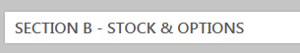
Text Only | None | - Inserts a non-actionable title  - Accepts any alphanumeric character or symbol | Use for titles and empty rows (as spacers) | - None | For labels, use nouns and noun phrases, not sentences or instructions  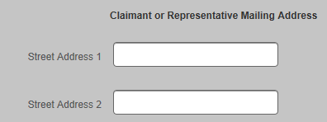
Entry  Entry, cont.  Entry, cont. | Text | - Creates a field that accepts any alphanumeric character and symbol  - A single-line field | Use for data that doesn’t fit well into any other type of field | - Presence/absence | For labels, use nouns and noun phrases, not sentences or instructions
 | Whole number | - Accepts manually entered numeric input that isn’t currency or in need of decimals  - Provides an up/down spinner that can be used to increase or decrease value  - Numbers are stored exactly as entered | Use for general numeric fields | - Presence/absence  - Range (upper and lower limits)  - Above/below a threshold | For labels, use nouns and noun phrases, not sentences or instructions
 | Decimal | - Accepts manually entered numeric input including values to right of decimal point  - Inserts an up/down spinner that can be used to increase or decrease value  - Automatically inserts four-place decimals  - Accepts up to 19 digits, 4 of which are to the right of the decimal | Use for numeric fields that require decimals | - Presence/absence  - Range (upper and lower limits)  - Above/below a threshold
 | Date | - Calendar widget appears with the field so dates can be entered with a couple of clicks  - Numeric input accepted  - Alphabetic input is accepted if the name or abbreviation of a month  - Any format is accepted, like 05-14-2013, or May 14, 2013;  - Creates a field that accepts two-digit years (for example, “13” for 2013) | Use for date fields | - Presence/absence  - Range (upper and lower limits)  - Above/below a set threshold | You can click the year at the top multiple times to expand choices to months, years, and decades
 | Money | - Creates a field that accepts numeric input only  - Automatically inserts four-place decimals  - Will not accept a dollar sign ($)  - No rounding  - Accepts up to 19 digits, 4 of which are to the right of the decimal | Use for money fields | - Presence/ absence  - Range (upper and lower limits)  - Above/below a threshold | Label in a way that makes it obvious that the field expresses an amount of money
Checkbox | Boolean | A box that can be selected and de-selected | Use a single box for a simple true|false response | - Presence/ absence  - If true  - If false | Be sure the labeling clearly indicates what is meant when the checkbox is selected and cleared
Drop-down List | Text | When clicked, a list of selectable items opens; the selected item is always visible, while the other options are only visible when the list is expanded  - Offers a predetermined list of options  - Usually used when a list exceeds 3-4 options  - Allows only one option to be selected | Use this when you want users to select only one item from a list of items | - Presence/ absence  - Equal to value | - Each item in the list must be a single line of text  - If the list is fewer than five items, consider using a button group or checkboxes instead  - Try to find a logical order to the items
Button Group (radio buttons) | Text | - A group of two or more selectable buttons  - Offers a predetermined list of options in a horizontal group  - Allows only one option to be selected by clicking a circular button | Use when you want users to select only one option from two or more choices | - Presence/ absence  - Equal to value | - Make sure options are mutually exclusive and equal  - Don’t use for a single binary (yes|no, true|false) choice  - Try to use no more than seven in a group
Memo | Long Text | - Creates a field that a multi-lined field that accepts any kind of alphanumeric input  - Allows multiple lines | Use when you want users to type long passages directly into the page | - Presence/absence | For labels, use nouns and noun phrases, not sentences or instructions
Table  Table, cont. | None | - The first line of tables always display a title  - The table can be formatted to include its own Entry, Checkbox, Drop-down, and Button Group elements  - Memos aren’t available in tables | Use tables to organize and consolidate related and repeating data | None | For labels, use nouns and noun phrases, not sentences or instructions  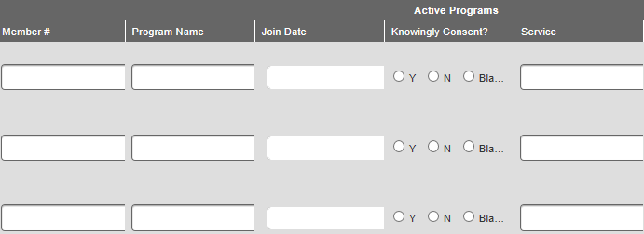
 | Entry column | Creates a column of entry fields (Text, Whole Number, Date, Decimal, or Money) in a table, repeated for each row | Use when you need an entry field in a table | For all data types:  - Presence/absence  - For all except Text:  - Range (upper and lower limits)  - Above/below a threshold
 | Button column | Creates a column of that contains two or more horizontal radio buttons in a table, repeated for each row | Use when you need to show an option for each line item in a table; users select only one option from two or more | - Presence/absence  - Equal to value | Try to use labels that are as short as possible.  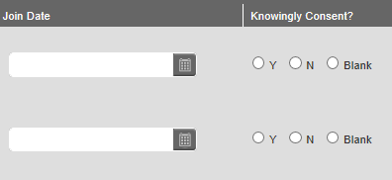
 | List column | Creates a column that of pre-populated drop-down lists in a table; same as Drop-down List | Same as Drop-down List | Same as Drop-down List | Same as Drop-down List
 | List db column | Created by the Systems team for the securities templates | Contact Systems

Appendix
E
“Add Item” Field Descriptions
This table provides definitions for each of the fields in the Add Item page of the Claim Form Configuration (CFC) tool.
Name | Description | Action
Item Status | The setting that lets the system know whether the item is ready for promotion | Leave the status as In Work for now
Text | The label seen onscreen for the field | Enter a title
Data Field Name | The name of the database column where the data for this field is saved; the name is defaulted from the database if the data already exists in in the database; otherwise, a new column is created in the database with a name derived from what is entered in the Text field | N/A
Details
Data Type | The behavior (or data type) of the field:  - For Entry items, the options are listed in the About Entry Fields table, above  - For Checkbox items, this is always Boolean (a simple yes|no or true|false option)  - For Drop-down and Button Group items, always Text  - For Memo items, this is always Long Text  - This field doesn’t apply to Text Only items | Make a selection based on the functionality you want in the field
Lower Bound | Displayed for all type of fields, except for Entry - Text and Memo fields; the lower limit or minimum value allowed | Enter a minimum value for the field
Upper Bound | Displayed for all types of fields, except for Entry - Text and Memo fields; the upper limit or maximum value allowed | Enter a maximum value for the field
Max Entry Length | The limit for the characters allowed to be entered into the field; not displayed for Memo fields | TBD
Field Width | The width of the white field that appears onscreen; not displayed for Memo fields | TBD
Default Value | The option to add a default entry (a word or number that is displayed automatically) for the field; not displayed for Memo fields | To set a pre-populated value, select Yes, then enter the text or value that you want to display
Required for Claim Entry | The option to require processors to enter text or a value during the workflows | Select Yes if you want the field to be required
Button Item #1 | For Button Groups only; the label for the first option; users can select only one option per group | Enter a short label for the option
Button Item #2 | For Button Groups only; the label for the second option in the button group; additional buttons can be added | Enter a short label for the option
List Item #1 | For Drop-Down fields only; the first option in the drop-down; users can select only one item from the group | Enter a short label for the option
List Item #2 | For Drop-Down fields only; the second option in the drop-down; additional options can be added | Enter a short label for the option
Project Party Mapping
Mapping To | The determination of whether to store information in this field in the name and claim records, or in the related name records | Accept the default of Name/Claim unless the field is specifically going to be used for related names
Applies To | The database object associated with the field; if a column for this data doesn’t already exist in the database table, a new column will be created | See Appendix F to determine which database table is associated with the field or best fits the data; select the appropriate database table from the Applies To drop-down
Map To Type | The selection in this drop-down allows you to further define specific database columns in which to store data. This field appears depending on the selection in the Applies To drop-down. See Appendix F for available options. | Make a selection based on what you need the CE form field to do. For example, if you’re defining a phone field, select whether the field will be for fax, business, cell, or home phone numbers.
Map To Field | The selection in this drop-down defines which field in the selected database is mapped to the field in your CE form. The options available in this drop-down vary depending on the selection in the Applies To and Map To Type drop-downs. | Make a selection based on what you need the CE field to do. For example, if you’re defining an address field, make a selection based on whether it’s a mail-to address, pay-to address, or zip code. If it’s a phone number, choose from fax, business, cell, or home.
Map To Value | Currently, this field appears only when the Map To Field drop-down is set to “TIN” so you can define the field as a social security number (SSN) or an employer identification number (EIN) | Select one of the options based on what you need the field to do.
Visibility
Claim Entry | The option to make the field editable, invisible, or view only during the Claim Entry workflows; if fields are hidden in Claim Entry, but set to be viewable in the Claim Processing workflow, the fields will be viewable by everyone who opens claims via Name/Claim Search | Select the option that you want to apply
Claim Processing | The option to make the field editable, invisible, or view only during the Claim Processing workflows; if fields are hidden in Claim Entry, but set to be viewable in the Claim Processing workflow, the fields will be viewable by everyone who opens claims via Name/Claim Search | Select the option that you want to apply
Web Entry | The option to make the field visible or view only in the online Web form; the default is View Only | Change to Invisible if the field if you don’t want the field to be seen in the online Web form

Appendix
F
Project Party Mapping
Options for the Project Party Mapping Field
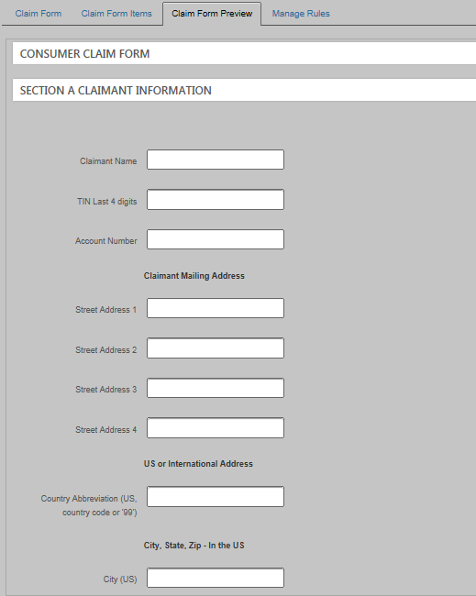
Name
Name
Alternate ID
Address
Address

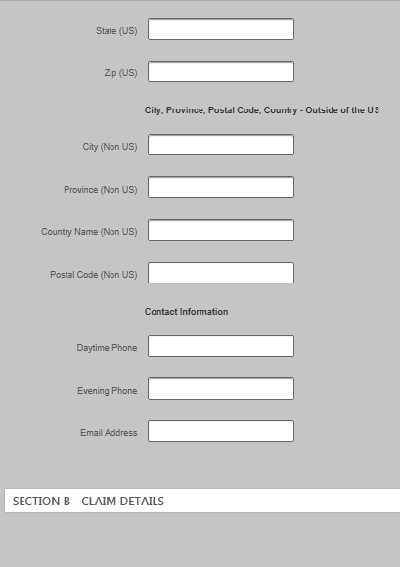
Address
Address
Phone Number
Phone Number

Email

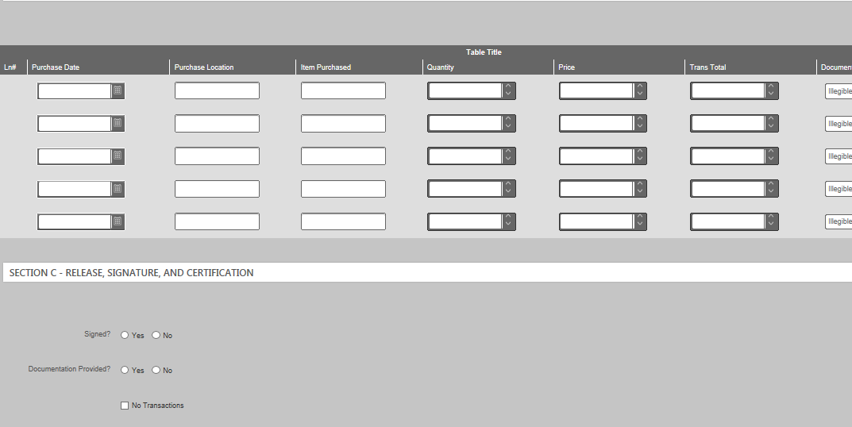
Claim
(all rows)

Claim Detail
(all rows)
Use the following table to determine what to select in the Project Party Mapping > Applies To field when you add new fields to a claim entry (CE) form via the CFC tool.
These options apply to all items except tables. (Tables are automatically mapped to Claim Detail.) If a Map To Field option is listed here but it you can’t see it onscreen, the field already exists in the CE form.
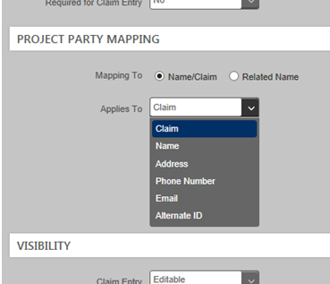

Mapping To (record) |  | Relationship Role | Applies To (database object) |  | Map To Type |  | Map To Field  (name of database column) |  | Map To Value | Usage Notes
Name/Claim |  | - | Claim Detail |  | - |  | - |  | - | Use for table columns
 |  |  | Claim |  | - |  | - |  | - | Use for everything that is not in a table or in Name, Address, Email, Phone, or Alt ID
 |  |  | Name |  | Any choice:  - N/A  - Adult  - Minor |  | Name 1 |  | - | Accommodates names AND addresses; considered ‘NameAddress 1’ in the database
 |  |  |  |  |  |  | Name Type |  | - | (Don’t use)
 |  |  |  |  |  |  | Name Type Other |  | - | (Don’t use)
 |  |  |  |  |  |  | TIN |  | EIN | -
 |  |  |  |  |  |  |  |  | SSN | -
 |  |  |  |  |  |  | TIN Last 4 digits |  | - | Use when you want to hide the full number for security reasons
 |  |  |  |  |  |  | TIN Type |  | -
 |  |  | Address |  | Mailing |  | Country Code |  | - | Use as “99” or with 2-digit country abbreviations
 |  |  |  |  |  |  | International City |  | - | -
 |  |  |  |  |  |  | International Country Name |  | - | -
 |  |  |  |  |  |  | International Postal Code |  | - | -
 |  |  |  |  |  |  | International Province/State |  | - | -
 |  |  |  |  |  |  | Is Address Mail-to |  | - | -
Mapping To (record) | Relation- ship Role |  |  | Applies To  (database object) |  | Map To Type |  | Map To Field  (name of database column) |  |  | Map To Value | Usage Notes
(Name/Claim, cont.) | - |  |  |  |  |  |  | Is Address Pay-to |  |  | - | -
 |  |  |  |  |  |  |  | NameAddress 2 |  |  | - | You can name these “Address 1,” “Address 2,” etc. if you want
 |  |  |  |  |  |  |  | NameAddress 3 |  |  | -
 |  |  |  |  |  |  |  | NameAddress 4 |  |  | -
 |  |  |  |  |  |  |  | NameAddress 5 |  |  | -
 |  |  |  |  |  |  |  | U.S. City |  |  | - | -
 |  |  |  |  |  |  |  | U.S. State |  |  | - | 2-letter abbreviation
 |  |  |  |  |  |  |  | U.S. Zip Code 5 |  |  | - | 5-digit ZIP code
 |  |  |  |  |  |  |  | U.S. Zip Plus 4Ext |  |  | - | 5-digit ZIP code + 4-digit extension
 |  |  |  | Phone Number |  | Any choice:  - Day  - Evening  - Unknown  - Fax  - Business  - Cell  - Home |  | Phone Extension |  |  | - | -
 |  |  |  |  |  |  |  | Phone Number |  |  |  | Consider labeling multiple options as “Day Phone” and “Evening Phone”
 |  |  |  | Email |  | Primary |  | Email Address |  |  | - | -
 |  |  |  | Alternate ID |  | Account Number |  | Account Identifier |  |  | - | Can be used for other unique identifiers, such as car VIN
Related Name | Any choice:  - Legal Guardian  - Contact  - Attorney  - Organization Owner  - Claimant  - Representative  - Lienholder |  |  | Related Name |  | - |  | Name 1 |  |  | - | Same as for Name
 |  |  |  |  |  |  |  | TIN |  |  | EIN | -
 |  |  |  |  |  |  |  |  |  |  | SSN | -
 |  |  |  |  |  |  |  | TIN Last 4 digits |  |  | - | Same as for Name
 |  |  |  |  |  |  |  | TIN Type |  |  | - | -
 |  |  |  | Related Address |  | Any choice:  - Mailing  - Physical  - Unknown |  | Same as Address |  |  | - | Same as Address
 |  |  |  | Related Phone |  | Same as for Phone |  | Same as for Phone |  |  | - | -
 |  |  |  | Related Email |  | Any choice:  - Primary  - Alternative  - Unknown |  | Email Address |  |  | - | -
 |  |  |  | Related Alternate ID |  | Any choice:  - Account Number  - Unknown  - Masked Account Number |  | Alternate Identifier |  |  | - | A “masked account number” is one that is replaced with asterisks for security reasons

Appendix
G
Condition Reasons
Object | Condition | Reason
Name/ Related Name | Incomplete | Missing name on claim
 | Information | Admin mail
 |  | Compliance reviewed (not on watch list)
 |  | Defendant claim
 |  | Employee
 |  | Lead plaintiff claim
 |  | Needs extra attention
 |  | Objections
 |  | OFAC match
 |  | Subject to backup withholdings
 |  | Unknown address
 |  | Withdrew previous exclusion request
 | No Further Action | Associated exclusion
 |  | Compliance reviewed (watch list hit)
 |  | Exclusion
 |  | Incomplete exclusion request
 |  | Late associated exclusion
 |  | Late Exclusion
 |  | No further action
 |  | Potential fraudulent filer
Address/ Related Address | Address Correction | Change of address
 |  | Name and address flag for review
 | Incomplete | Address missing, incomplete, or invalid
 | Ineligible | Invalid per terms of case
Phone/  Related Phone | Incomplete | Missing, incomplete, or invalid
 | Ineligible | Invalid per terms of case
Email | Incomplete | Missing, incomplete, or invalid
 | Ineligible | Invalid per terms of case
Claim | Incomplete | Blank detail page, no docs
 |  | Documentation is illegible
 |  | Documentation inadequate
 |  | Documentation not for eligible security

Object |  | Condition | Reason
Claim, cont. |  | Incomplete, cont. | Late claim
 |  |  | No declaration of signature
 |  |  | No documentation provided
 |  |  | No signature
 |  | Ineligible | Duplicate claim
 |  |  | No loss
 |  | Information | Add to file
 |  |  | Barroway Topaz…
 |  |  | Blank detail page, no docs
 |  |  | Claim created, not scanned
 |  |  | Claim reviewed by QA
 |  |  | Contesting GCG determination
 |  |  | Copy POC
 |  |  | Deficiency response
 |  |  | Doc review
 |  |  | Electronically filed claim
 |  |  | Foreign claim
 |  |  | Foreign currency claim
 |  |  | Large claim pending
 |  |  | Large loss, reviewed, claim deficient
 |  |  | Large claim, reviewed, not deficient
 |  |  | Low loss, doc review
 |  |  | Name of beneficiary owner differs on POC
 |  |  | No longer contesting
 |  |  | Payment objection
 |  |  | Postcard mailed
 |  |  | Reassigned images
 |  |  | Reviewed by processing
 |  |  | Reviewed, not duplicate
 |  |  | Short sale
 |  |  | UND, rejection letter
 |  | No Further Action | Associated exclusion
 |  |  | Claim is withdrawn
 |  |  | Claim shouldn’t have been created
 |  |  | Exclusion
 |  |  | Incomplete exclusion request
 |  |  | Late associated exclusion
 |  |  | Late exclusion
 |  |  | No further action
 |  | No Doc Review | Not chosen for doc review
 | Object | Condition |  | Reason
 | Claim Detail | Incomplete |  | Documentation is illegible
 |  |  |  | Documentation is inadequate
 |  |  |  | Invalid transaction price
 |  |  |  | Invalid transaction total
 |  |  |  | Missing item, option transaction
 |  |  |  | Missing transaction date
 |  |  |  | No documentation provided
 |  |  |  | No purchase documentation
 |  |  |  | No sale documentation
 |  |  |  | Option month for option trade is invalid
 |  |  |  | Option not found based on data provided
 |  |  |  | Option strike price for option traded is invalid
 |  |  |  | Option year for option trade is invalid
 |  |  |  | Shares transferred or gifted to account
 |  |  |  | Shares transferred or gifted out of account
 |  | Ineligible |  | Date of purchase out of range
 |  |  |  | Doc for transaction is not for eligible security
 |  |  |  | Duplicate line
 |  |  |  | Exclude transaction
 |  |  |  | No purchase during period
 |  |  |  | Security is ineligible
 |  | Information |  | Date out of range
 |  |  |  | Net amt doesn’t match computed total
 |  |  |  | No price required for this transaction
 |  |  |  | Total not required
 |  |  |  | Trade price is out of range
 |  | No Further Action |  | Claim detail deleted

Index

add people to 20/20, 3
Admin Mail workflow, 24
Applies To field, 97
assiging roles to a group, 36
assign people to projects, 34
assigning roles, 36
bookmarks, 9
browser compatibility, 3
building a claim entry form, 45
building blocks, claim entry form, 89
business rules. See if tests
claim entry form
building, 45
building blocks, 89
CFC tool, 45
defaults, 42
entry fields, defined, 52
functionality, 41
limits, 42
mapping to database, 93, 97
planning, 41
planning worksheet, 87
promoting, 68
status, 68
structure, 43
templates, 45
text only items, 50
usability, 42
Claim Entry workflows, 20
claim form
definitions, 4
Claim Form Configurator tool
CFC tool, 45
Claim IDs, defined, 26
Claim Number, defined, 25
Claim Processing workflow, 23
claim records, defined, 25
classifications, 11
cloning, 35
colored tabs, 2
condition reasons
reference chart, 100
controls in Internet Explorer, 3
conventions
bold font, 2
numbering, 26
create new doc from image, 12
Deficiency Processing workflow, 23
definitions, 4
Exclusion Processing workflow, 24
exclusions, 29
filtering table columns, 5
format, 2
Help, 4
icons, defined, 2
IE. See Internet Explorer
if tests, 64
image viewer
create new doc, 12
overview, 9
improvements to 20/20, 4
Internet Explorer
controls, 3
multiple tabs of, 3
layout of 20/20, 2
mapping, claim entry form, 93, 97
Name Number, defined, 25
name record, defined, 25
name/claim search menu, 9
new doc from image, 12
new people, adding to 20/20, 3
NME
numbering, 26
numbering, 26
objections, 29
online Help, 4
overview, 2
page ranges, 11
planning the claim entry form, 41
planning worksheet, claim entry form, 87
practice
assigning individual roles, 36
assigning roles to a group, 36
bookmarks, 9
classifying docs, 12
cloning, 35
creating new docs from images, 12
filtering tables columns, 7
reassigning work to peers, 27
recording an objection, 29
recording exclusions, 29
searching, 8
showing/hiding columns, 6
sorting columns, 6
uploading docs, 38
workflows, 24
project services, 34
project setup, 34
promoting, claim entry form, 68
reassign work to peers, 27
related name ID, 26
related name record, defined, 26
reports, 17
searches, 7
show/hide table columns, 5
sorting table columns, 5
status, claim entry form, 68
suggestions, 4
table columns
filtering, 5
show/hide, 5
tables
adding to claim entry form, 57
tabs, multiple instances of 20/20, 3
technical help, 4
templates, claim form setup, 45
terminology, 4
text only items, claim entry form, 50
workflows
overview, 19
roles for, 20

